# Use Cases

## 1 General

(To be written)

## 2 Situation Triggered

(To be written)

## 3 User Triggered

## 3.1 General

(To be written)

## 3.2 What do you see?

The answer is formed by counting the number of thing and stuff instances in view. Plural form is used if required. Things in confidence order is spelled first, then stuff. Confidence level determines “sure” from “probable”.

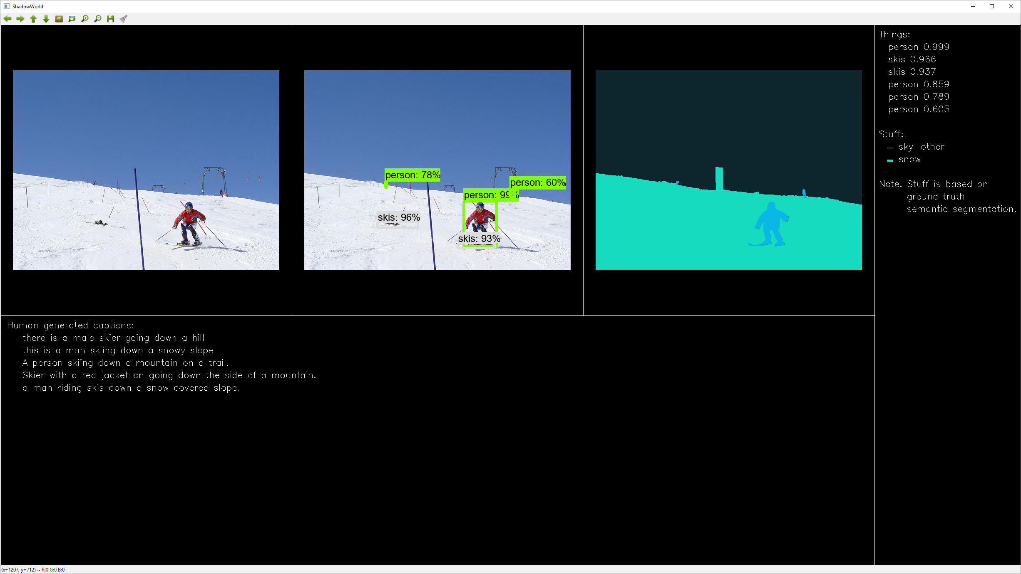

“Two persons, two skis. Probably also two persons. Sky, snow.”

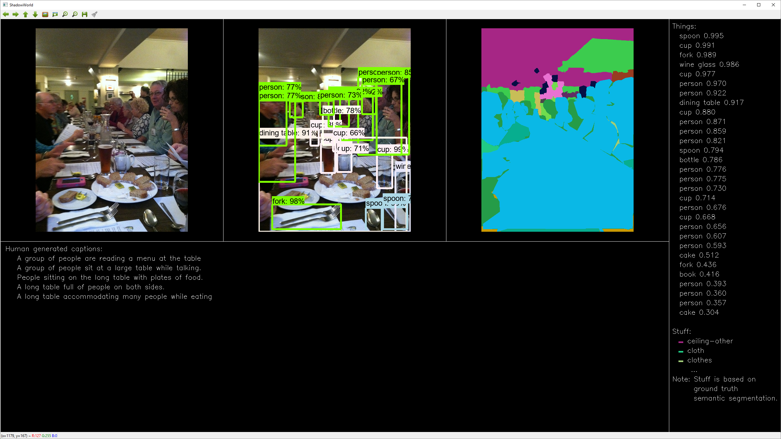

“Spoon, three cups, fork, wine class, five persons, dining table. Probably also spoon, bottle, ten persons, two cups, two cakes, fork, book. Ceiling, clothes”

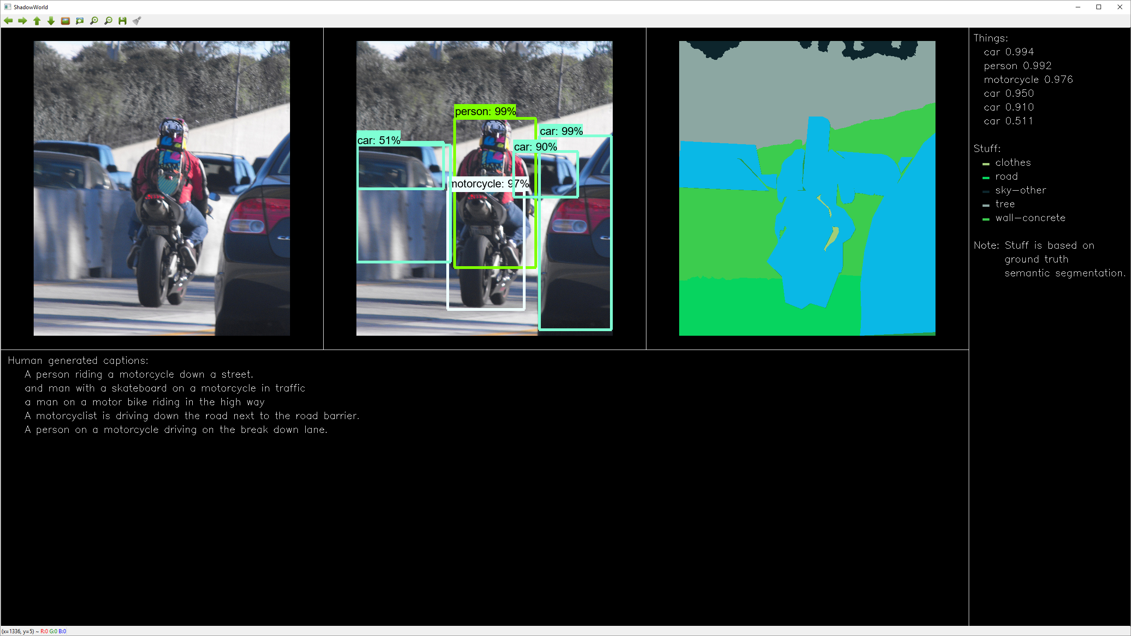

“Three cars, person, motorcycle. Probably also car. Clothes, road, sky, tree, wall.”

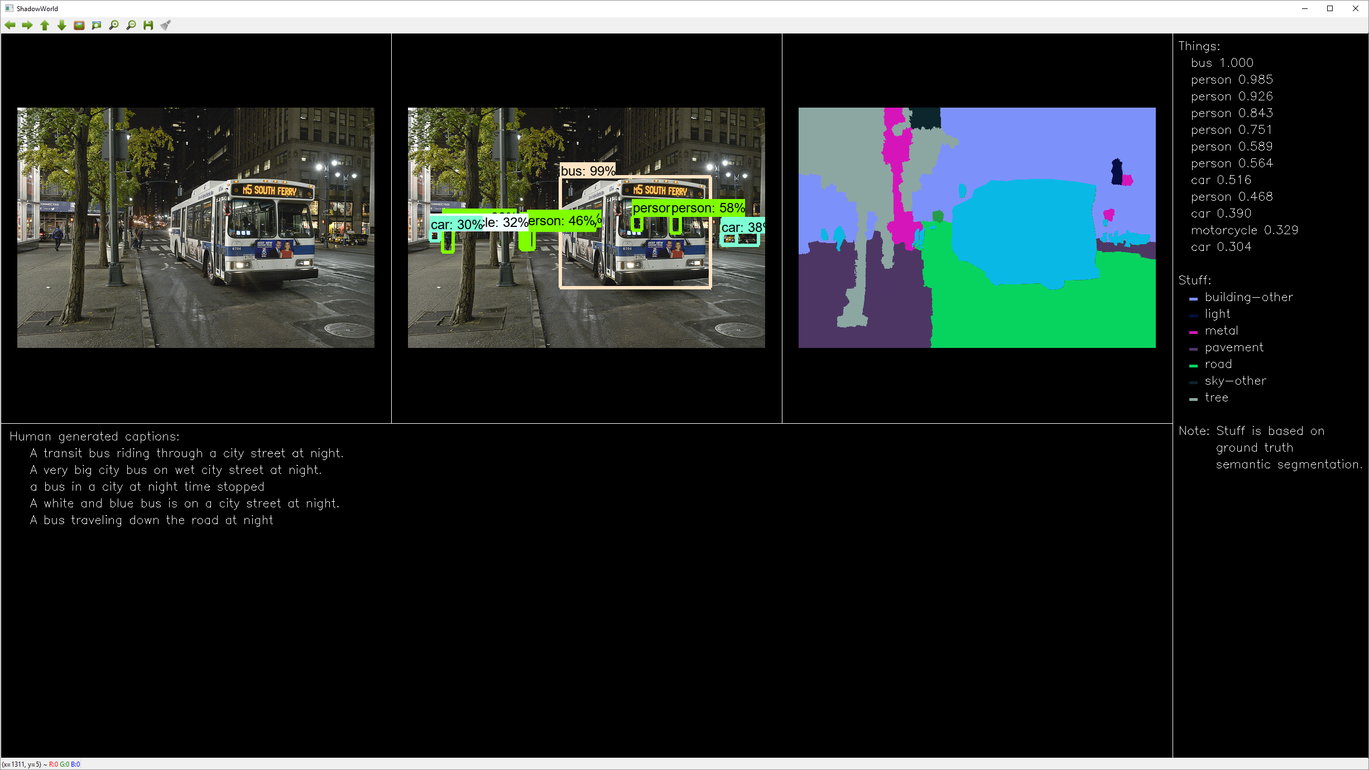

“Bus, three persons. Probably also four persons, three cars, motorcycle. Building, light, metal, pavement, road, sky, tree.”

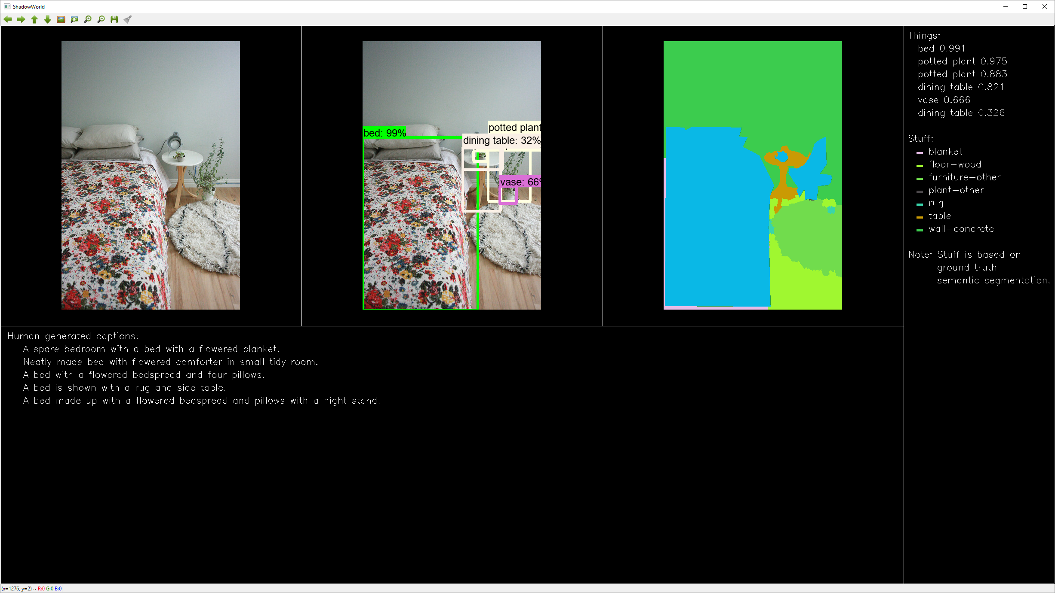

“Bed, two potted plants, dining table. Probably also vase, dining table. Blanket, floor, rug, wall.”

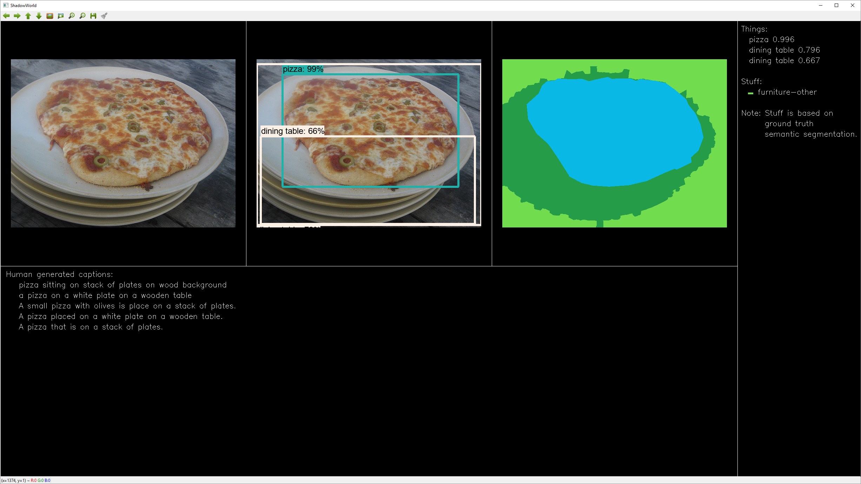

“Pizza. Probably also dining table. Furniture.”

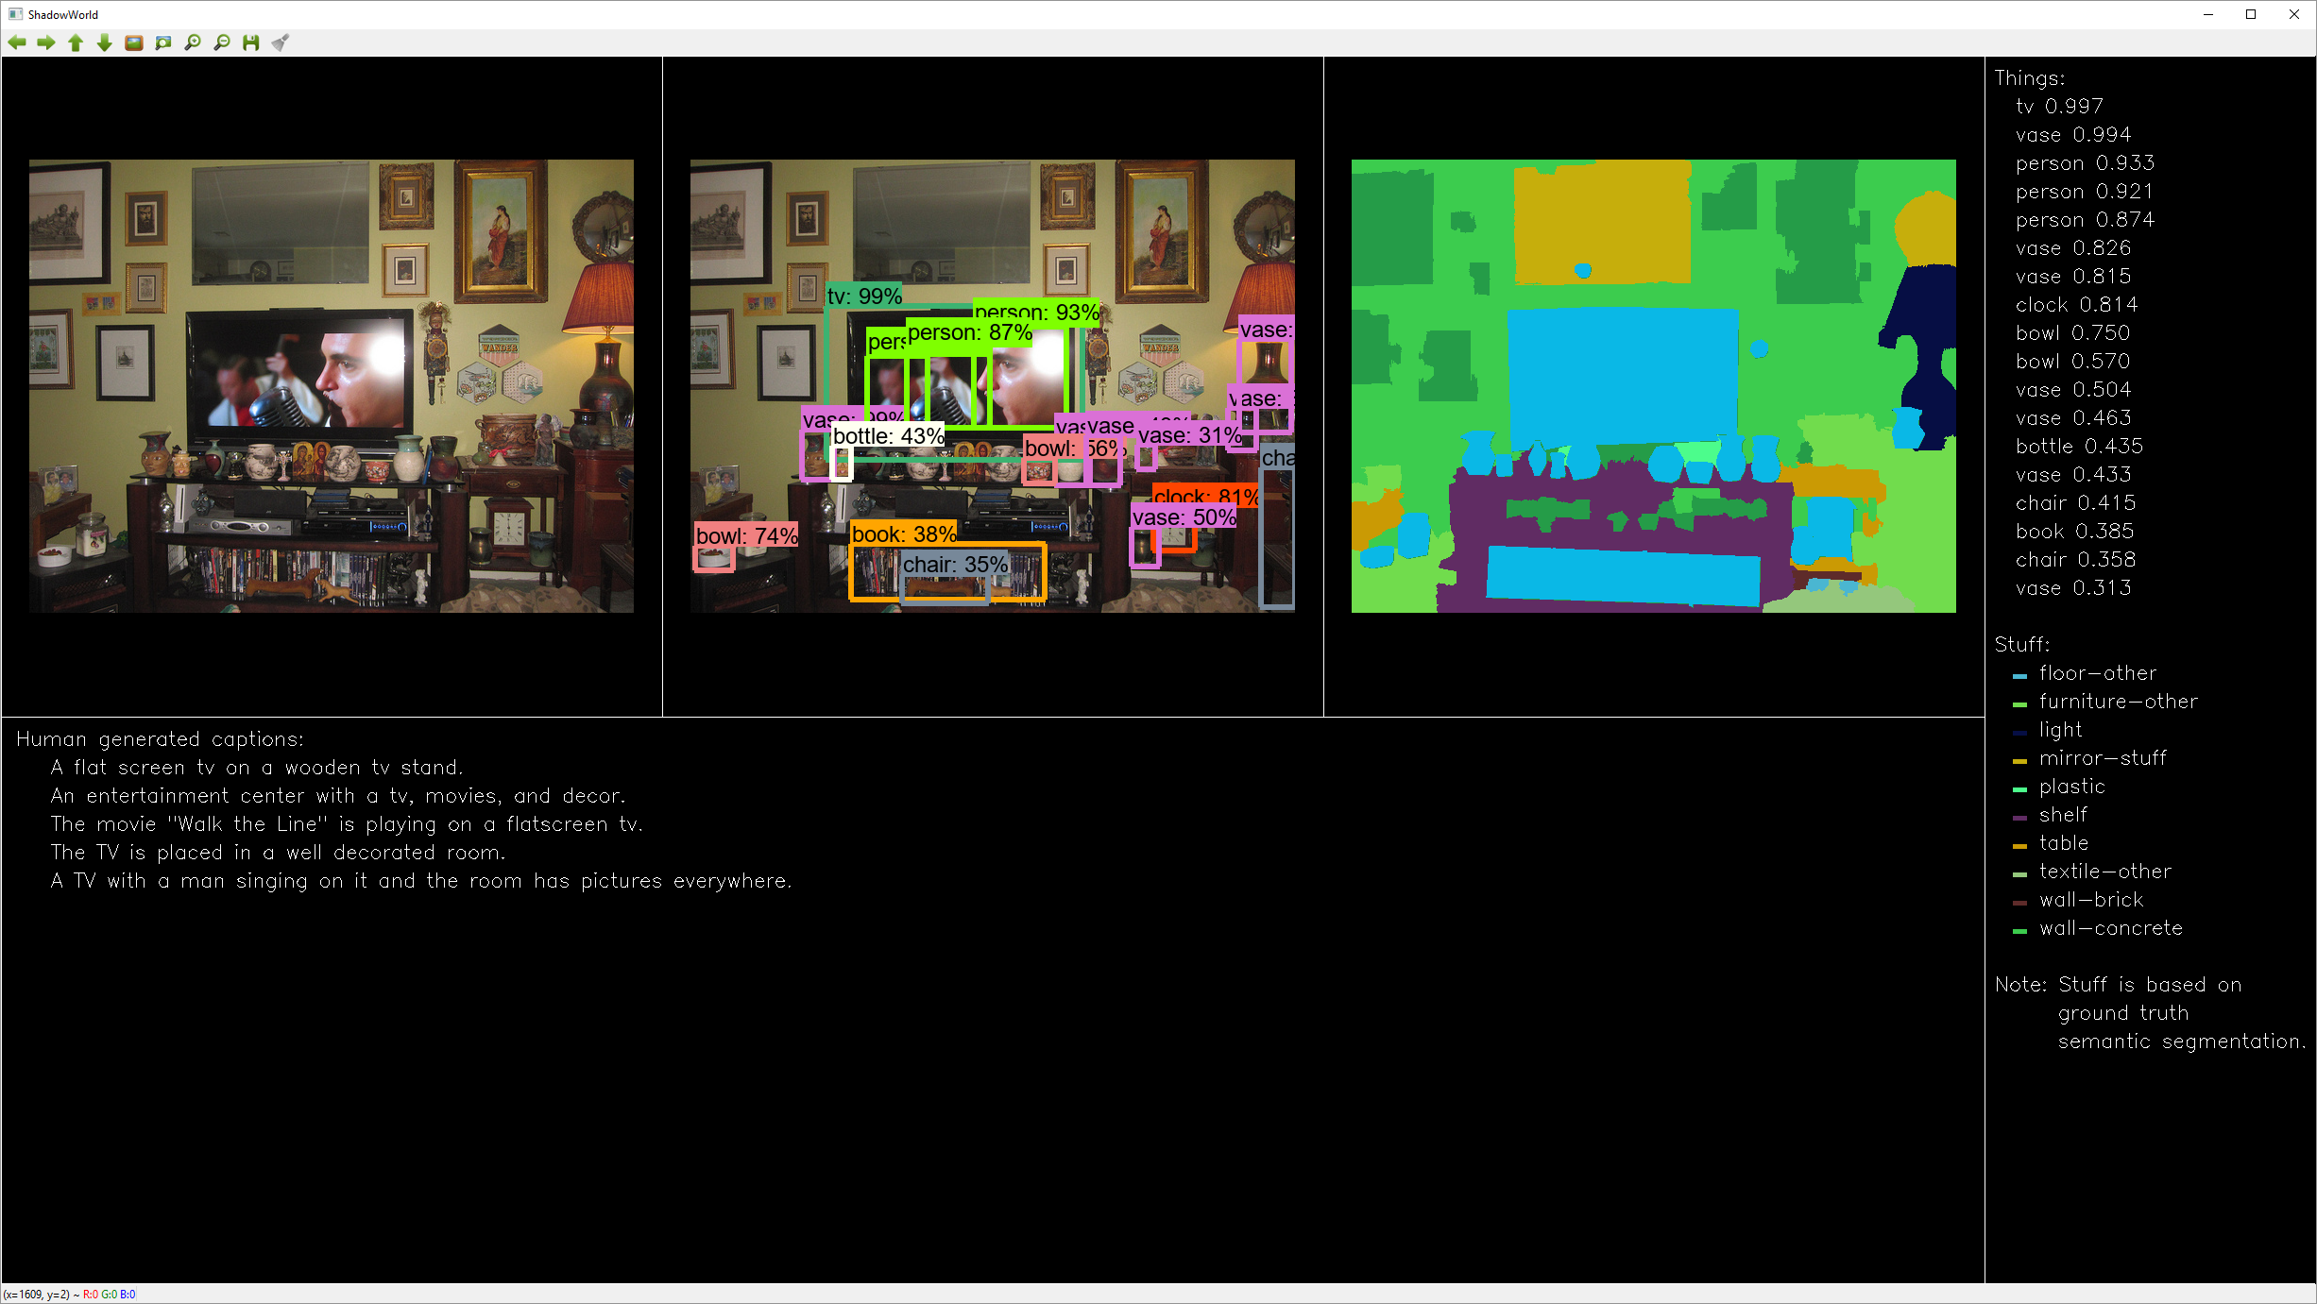

“Tv, three vases, three persons, clock. Probably also two bowls, three vases, bottle, two chairs, book. Floor, furniture, light, mirror, plastic, shelf, table, textile, wall.”

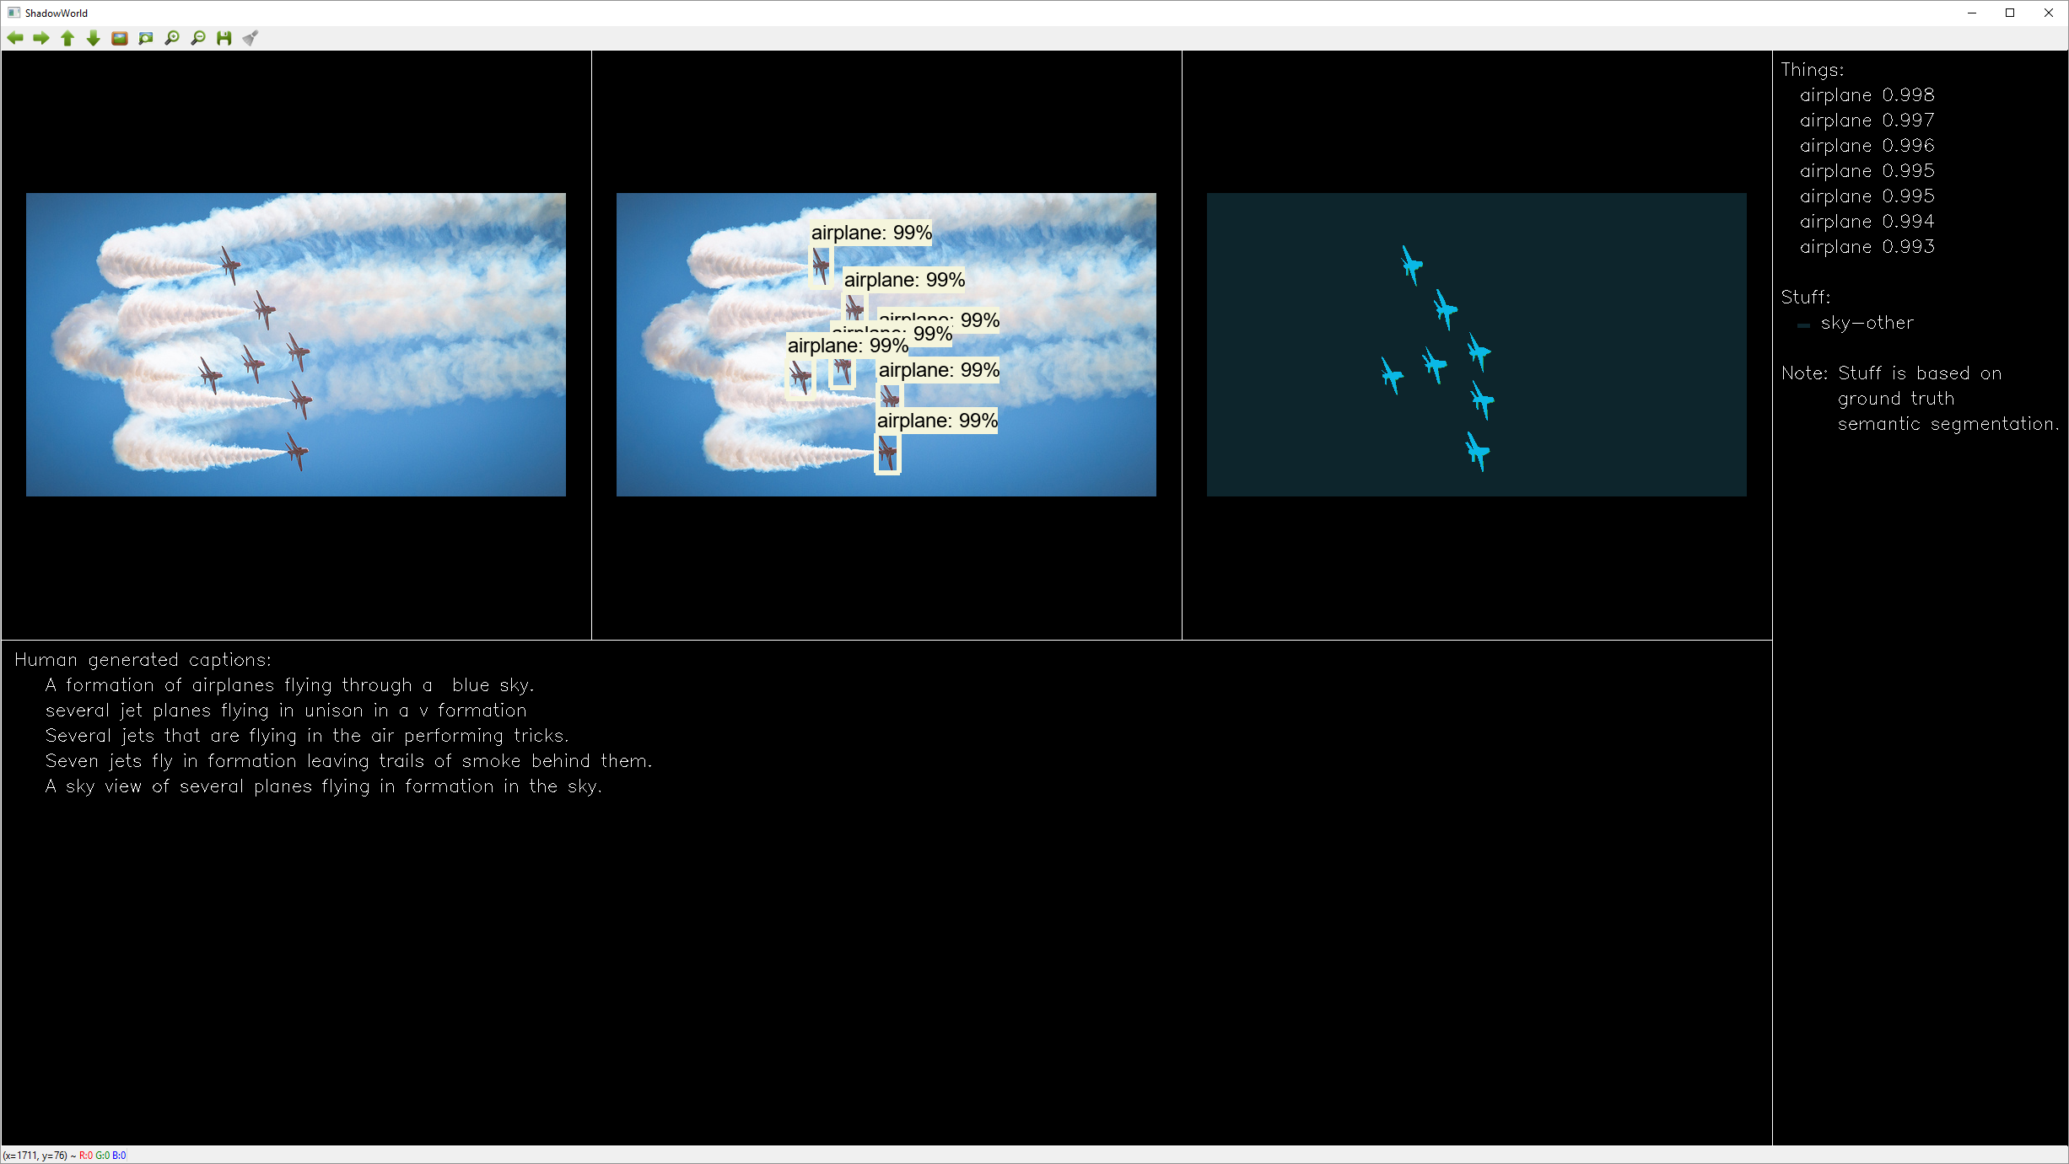

“Seven airplanes. Sky.”

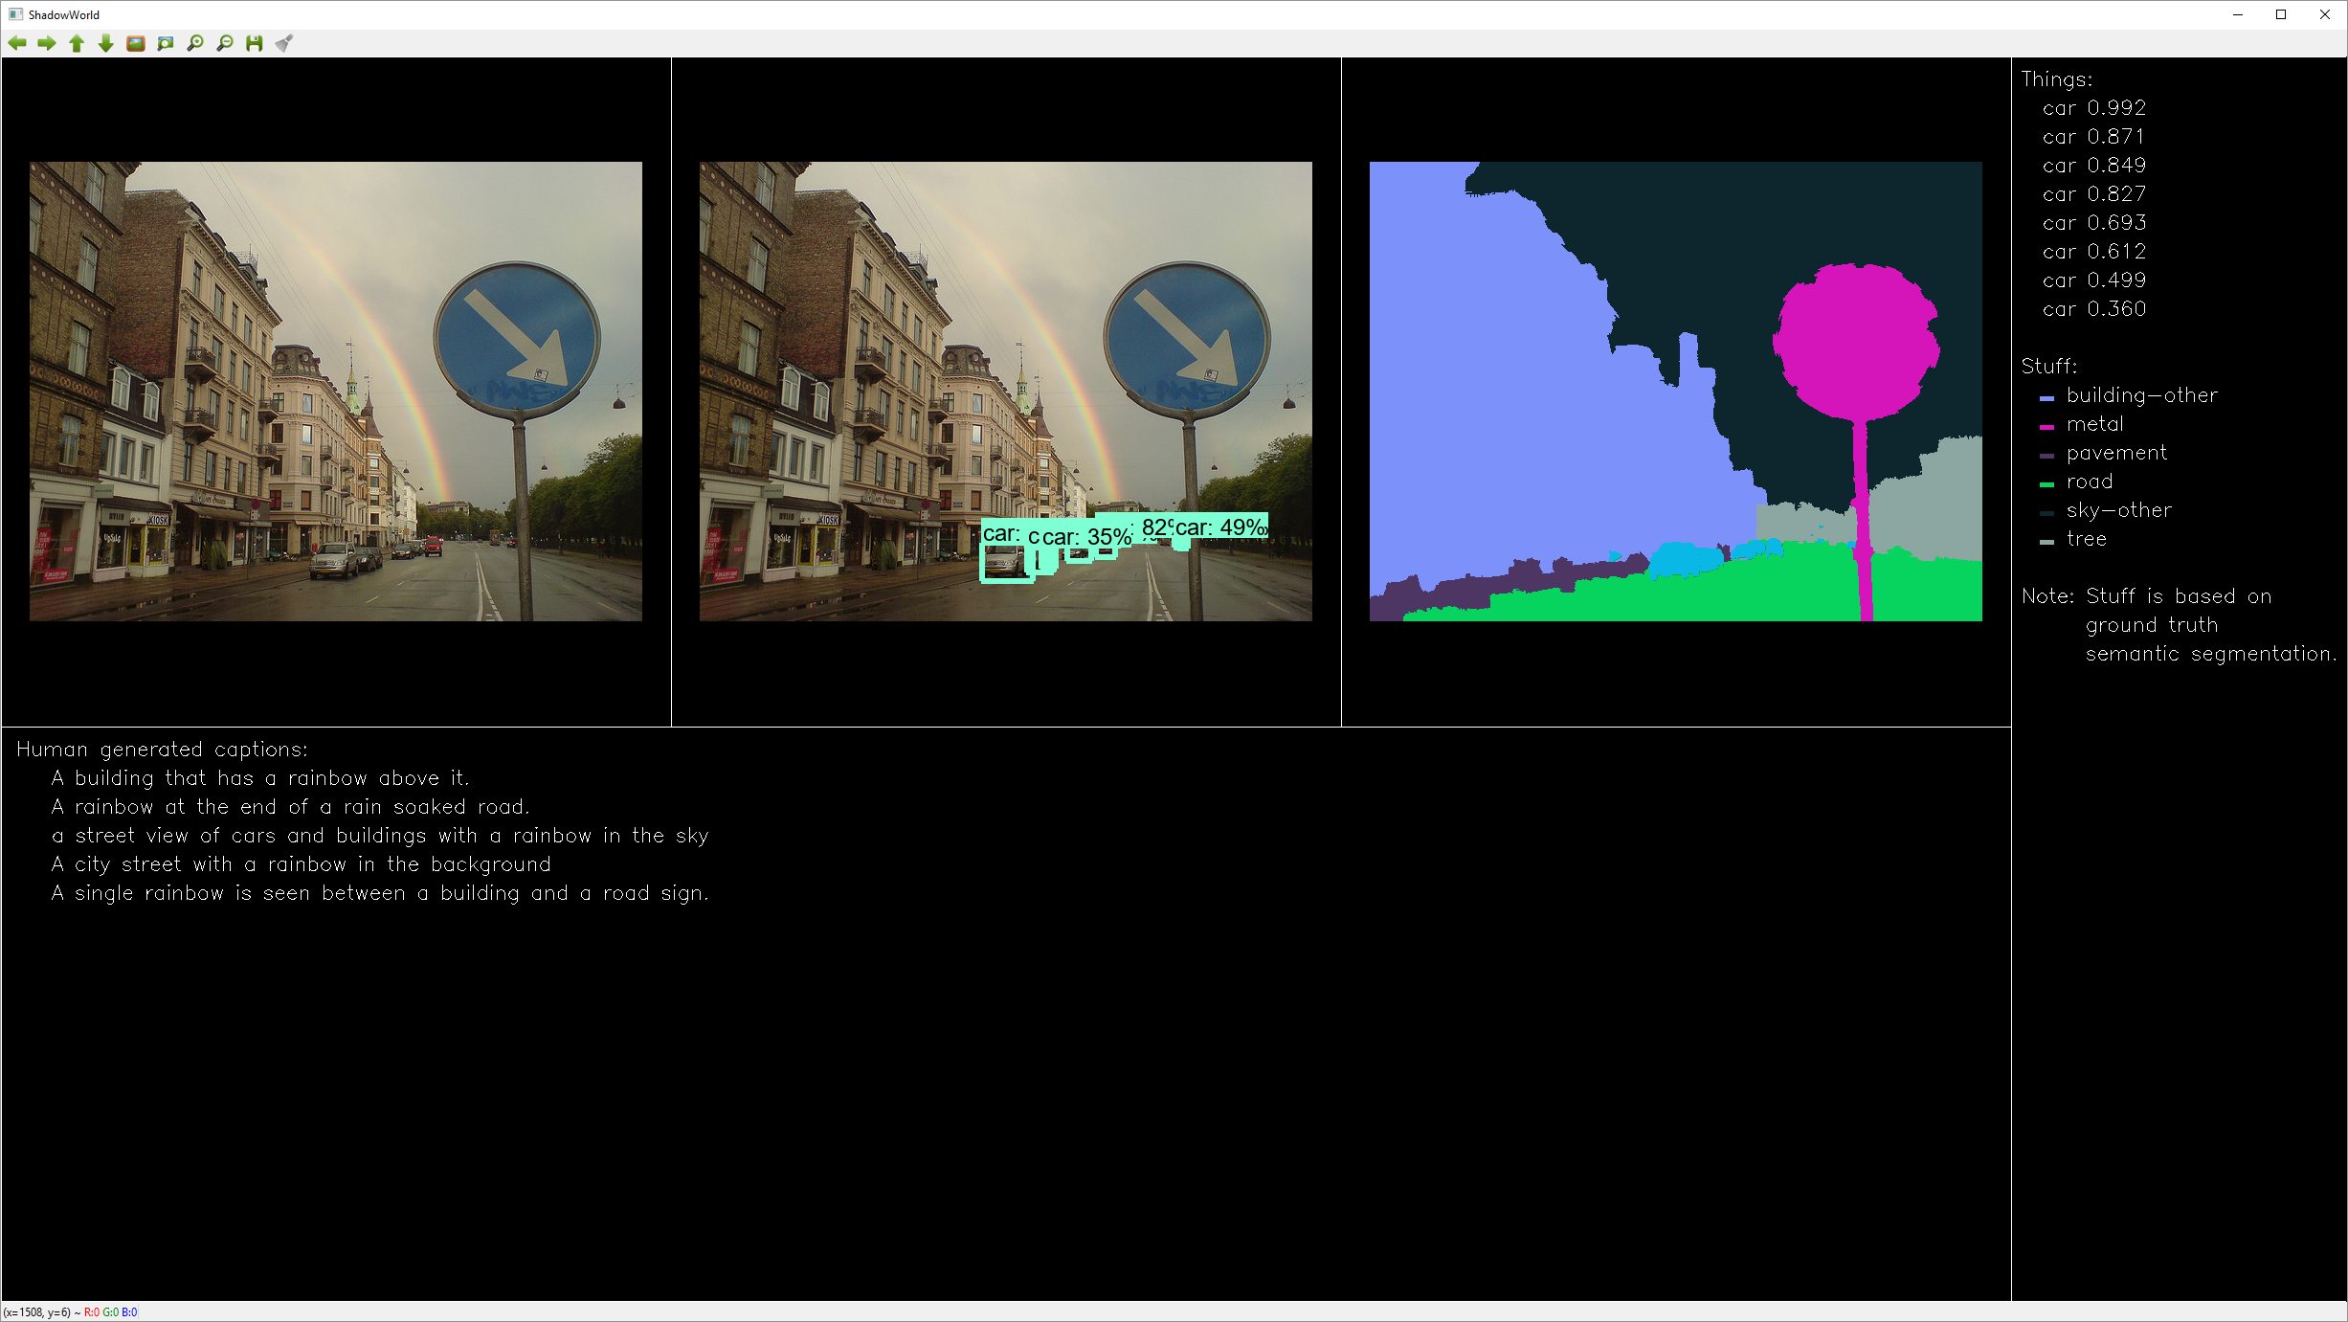

“Four cars. Probably also four cars. Building, metal, pavement, road, sky, tree.”

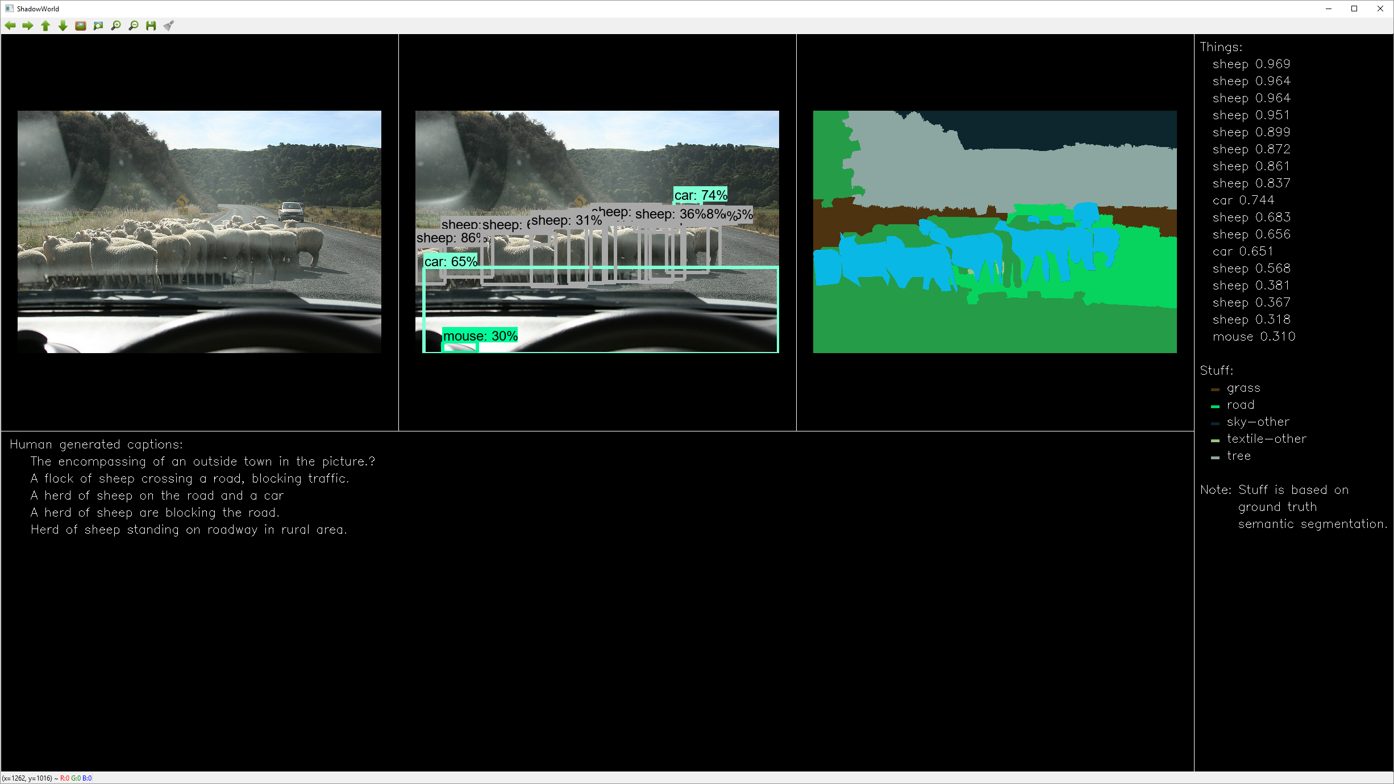

“Eight sheeps. Probably also two cars, six sheeps, mouse. Grass, road, sky, tree.”

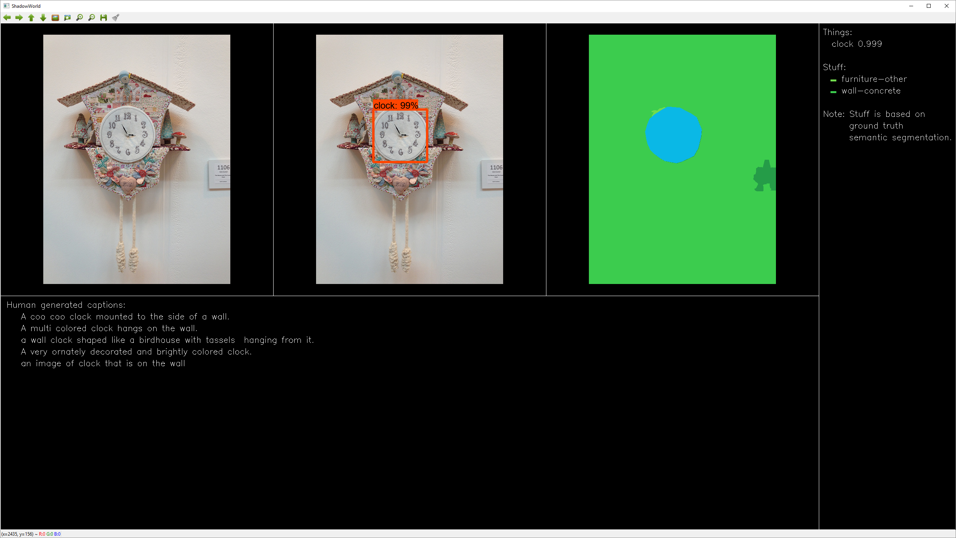

“Clock. Furniture, wall.”

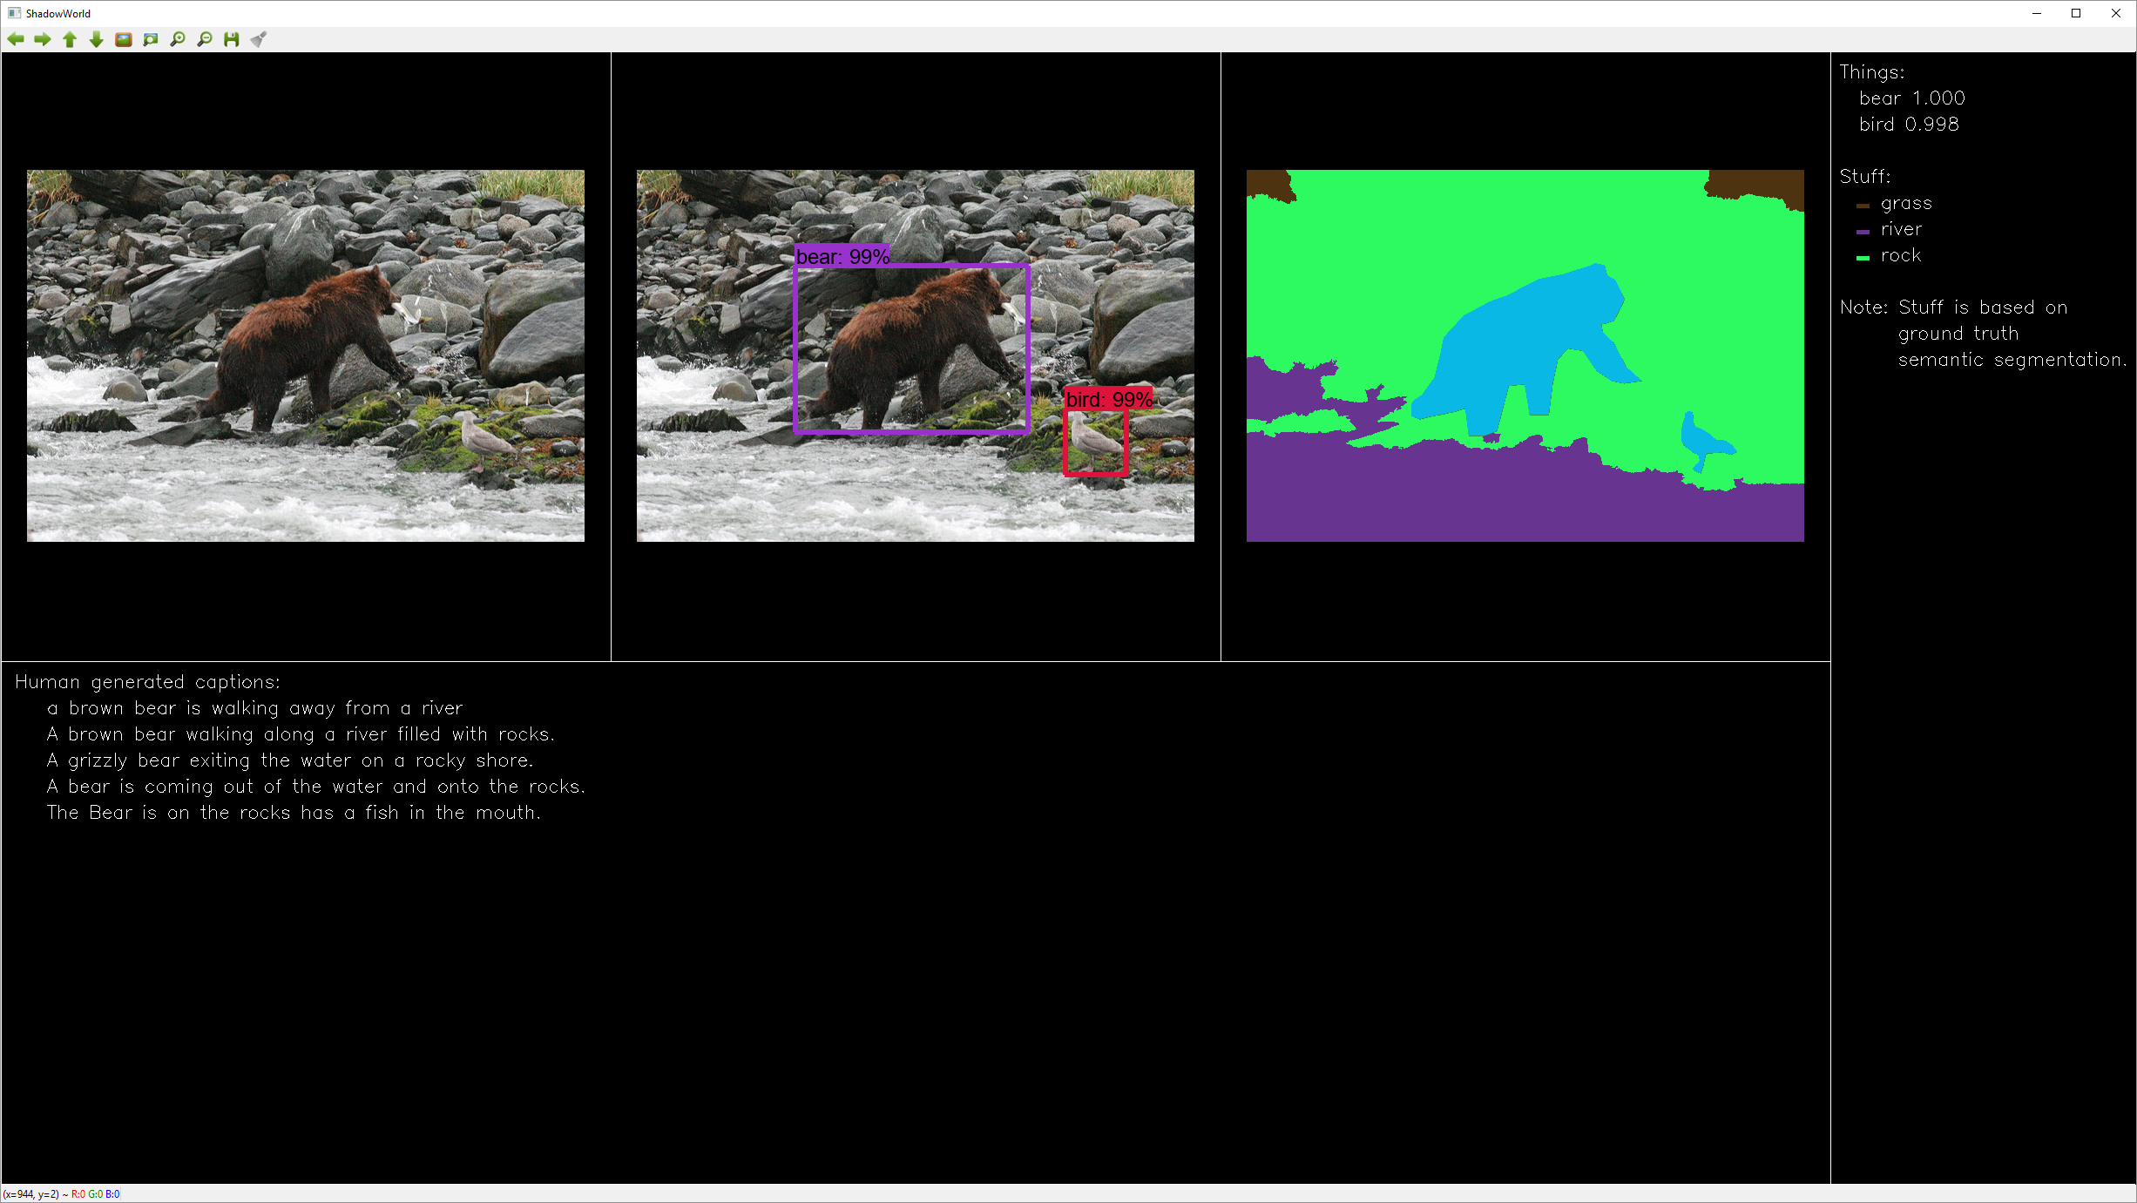

“Bear, bird. Grass, river, rock.”

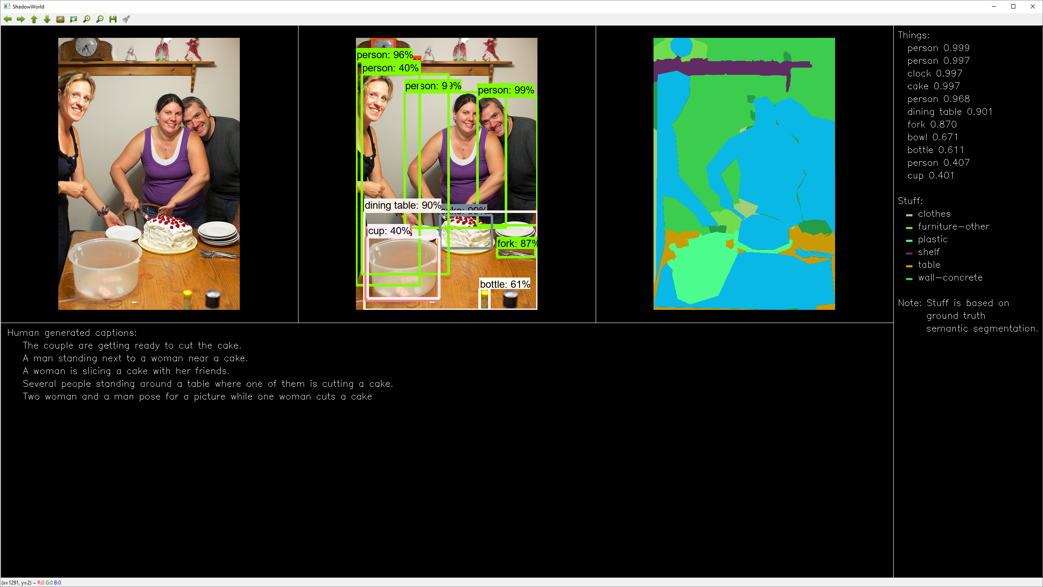

“Three persons, clock, cake, dining table, fork. Probably also bowl, bottle, person, cup. Clothes, furniture, plastic, shelf, table, wall.”

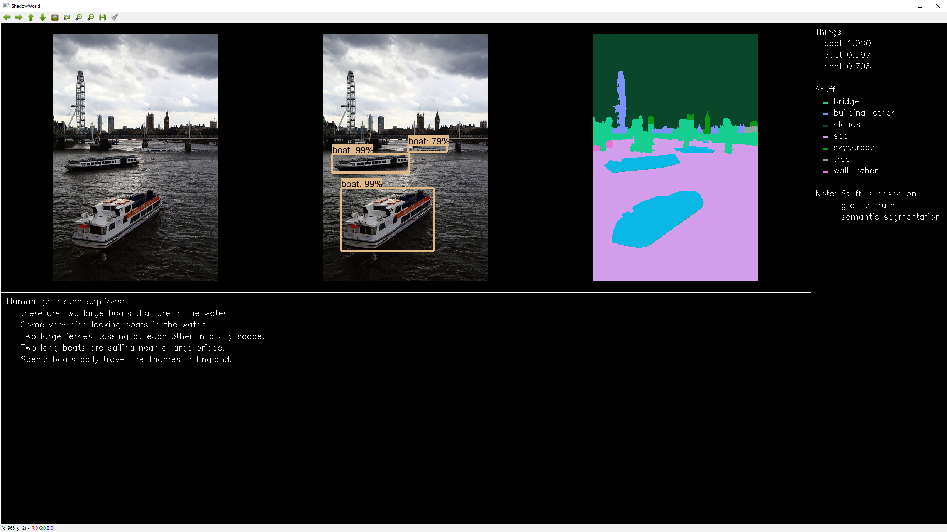

“Three boats. Bridge, building, clouds, sea, skyscraper, tree, wall.”

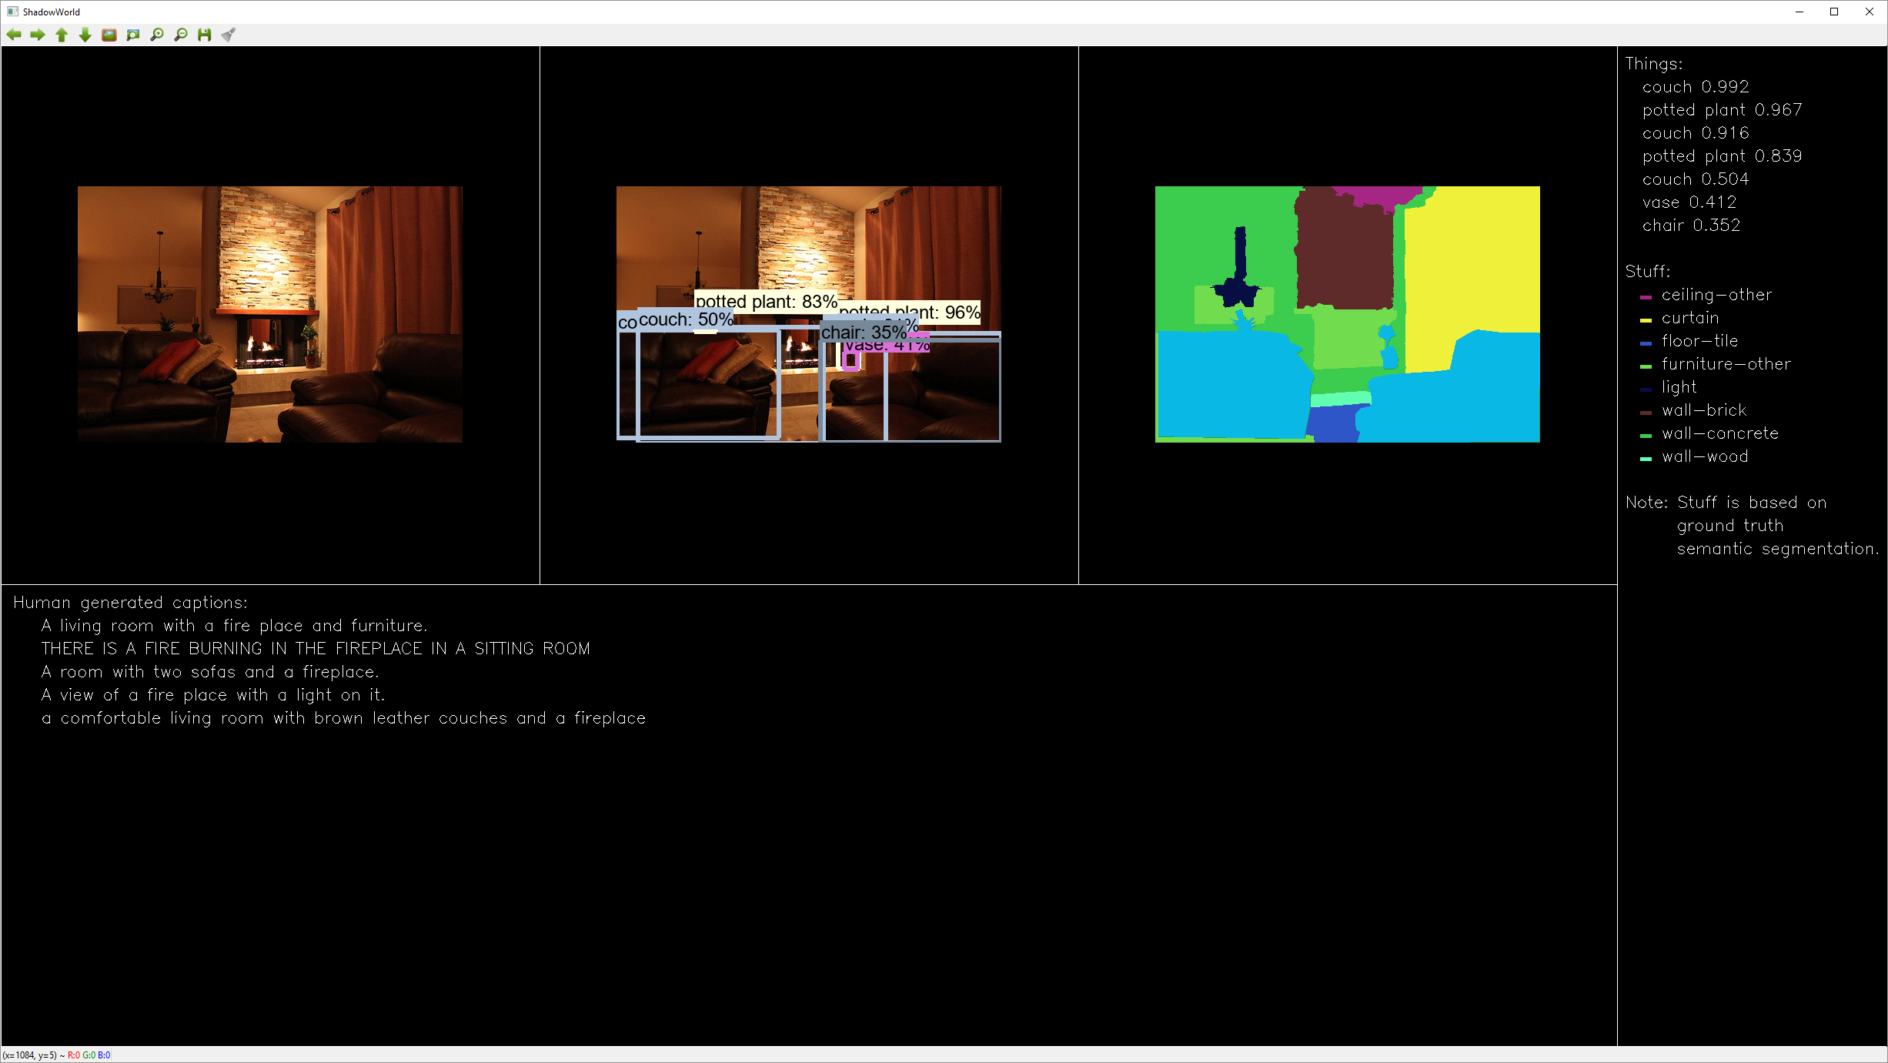

“Two couches, two potted plants. Probably also couch, vase, chair. Ceiling, curtain, floor, furniture, light, wall.”

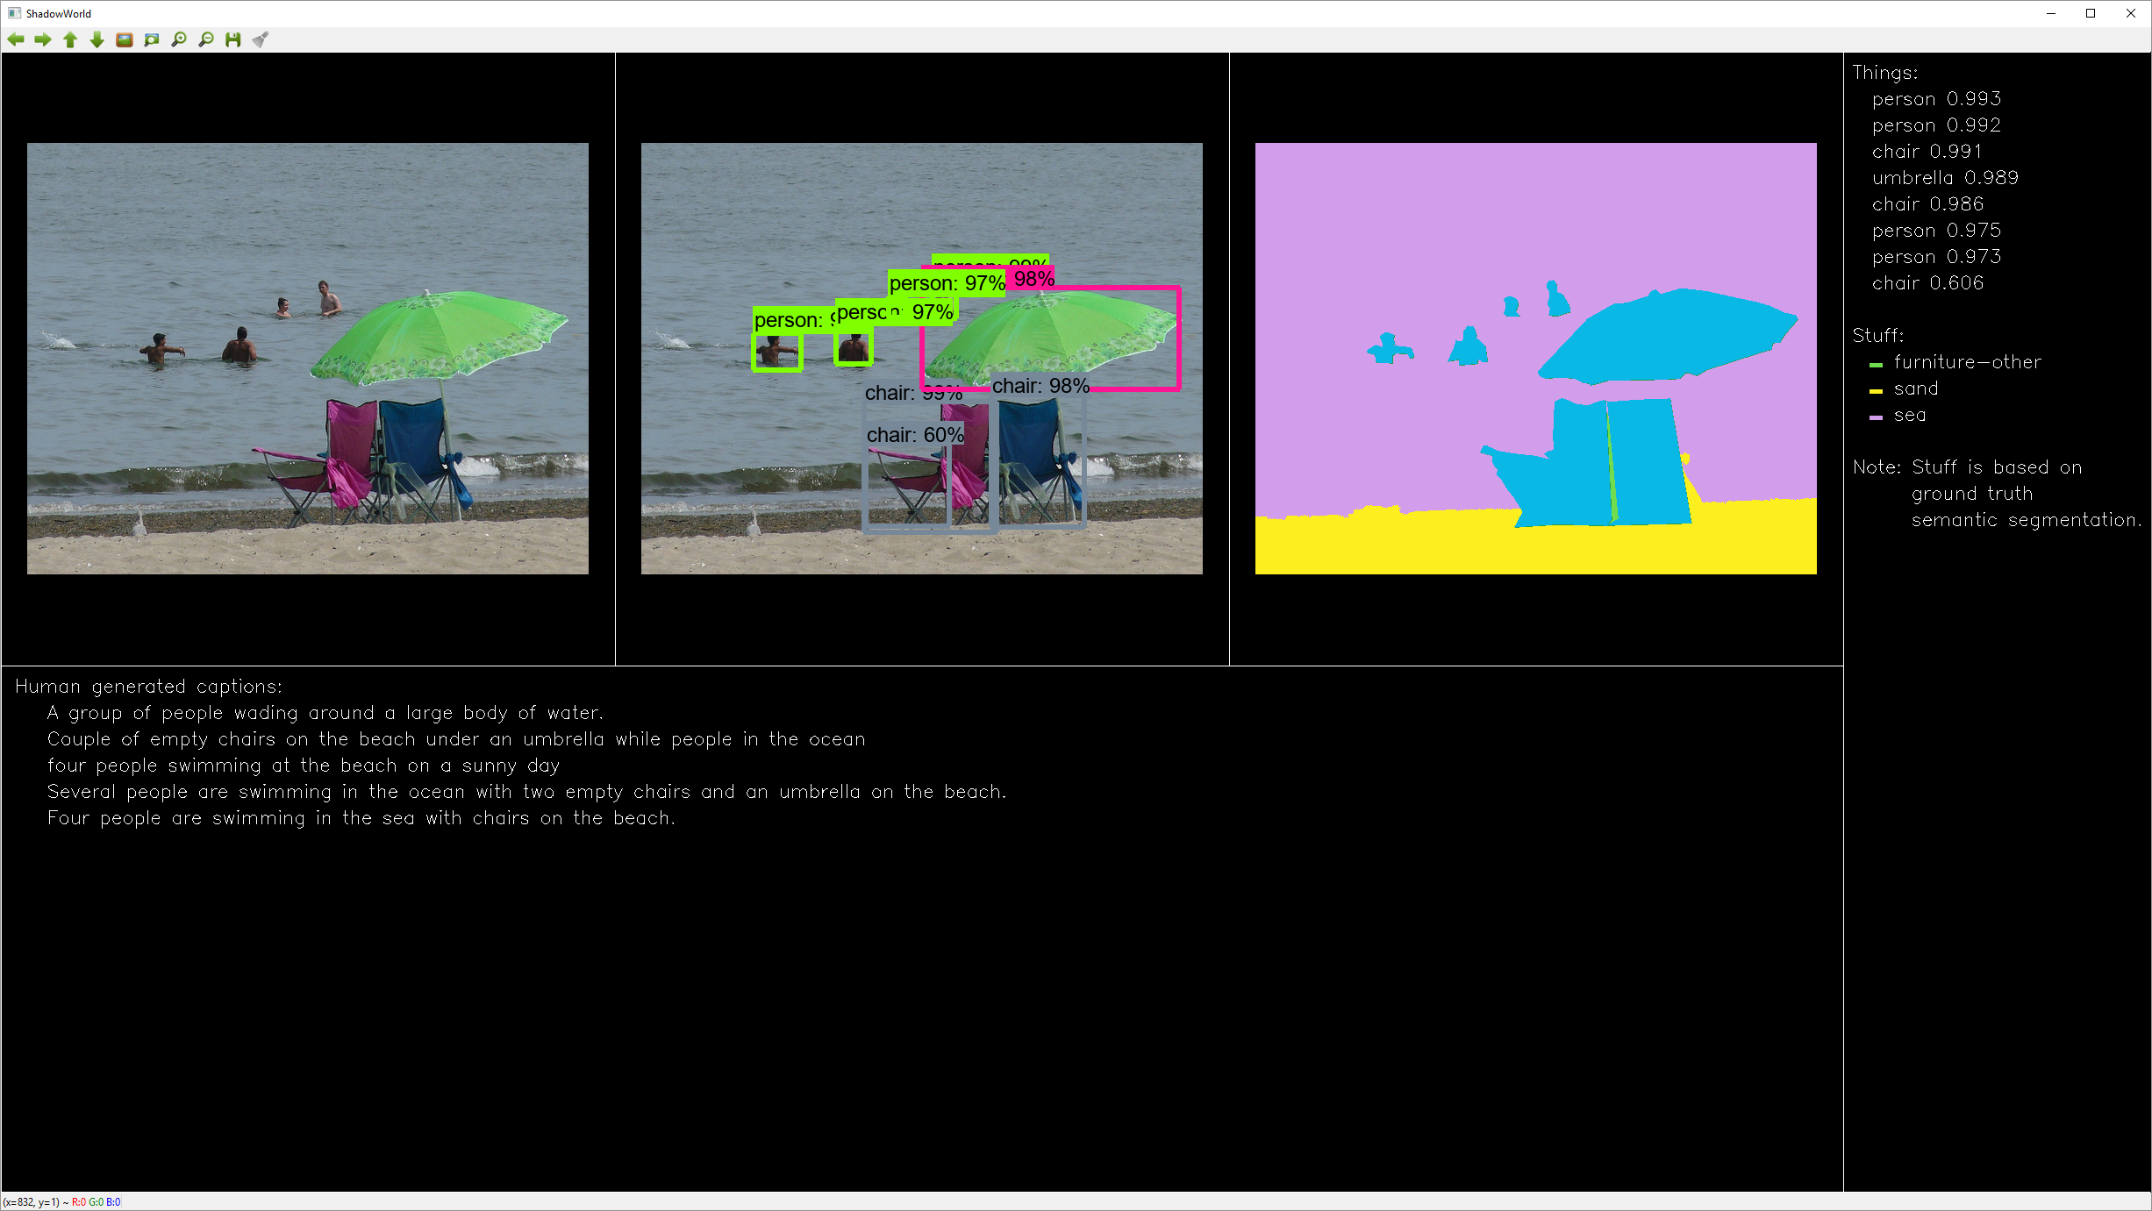

“Four persons, two chairs, umbrella. Probably also chair, Furniture, sand, sea.”

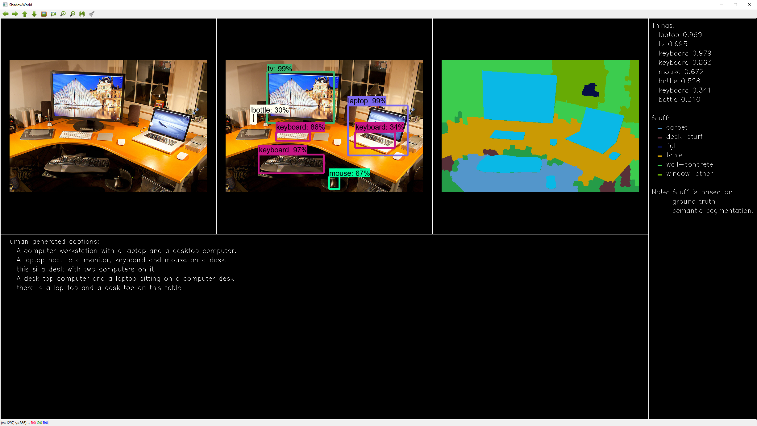

“Laptop, tv, two keyboards. Probably also mouse, two bottles, keyboard. Carpet. desk, light, table, wall, window.”

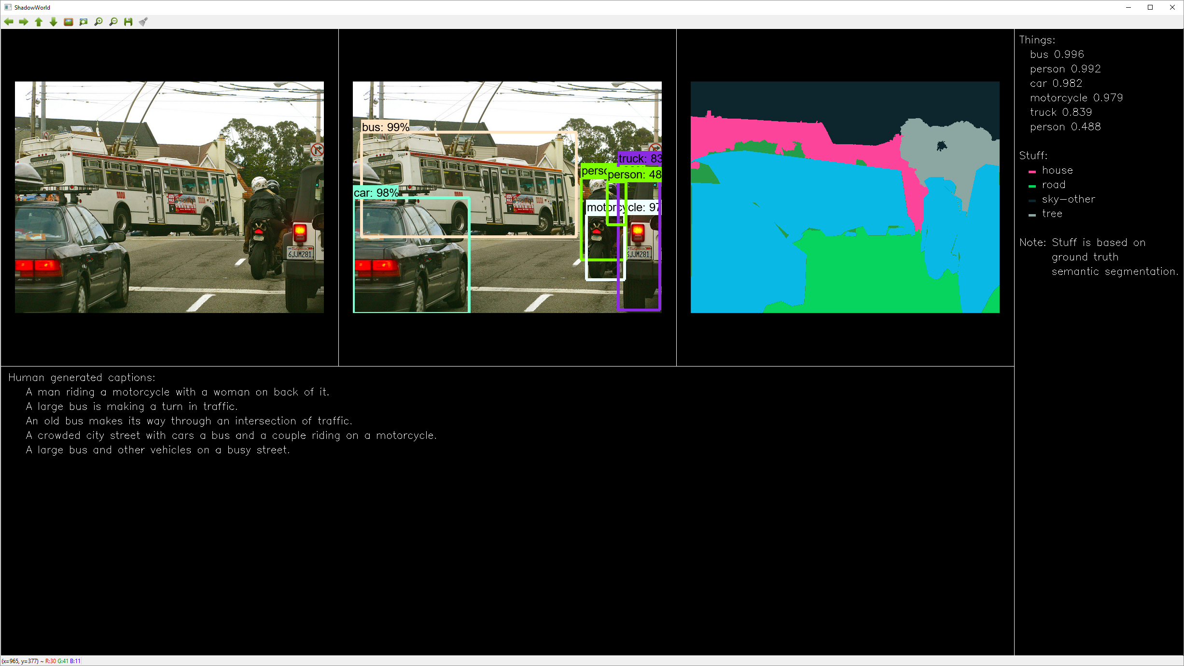

“Bus, person, car, motorcycle, truck. Probably also person. House, road, sky, tree.”

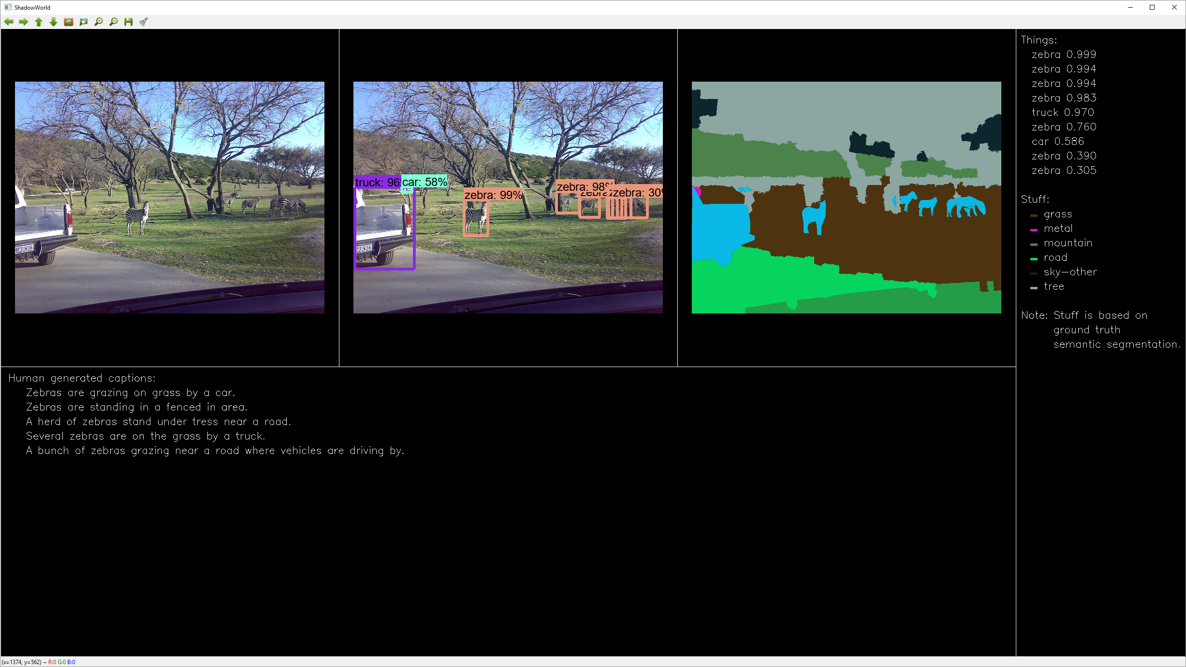

“Four zebras, truck. Probably also three zebras, car. Grass, metal, mountain, road, sky, tree.”

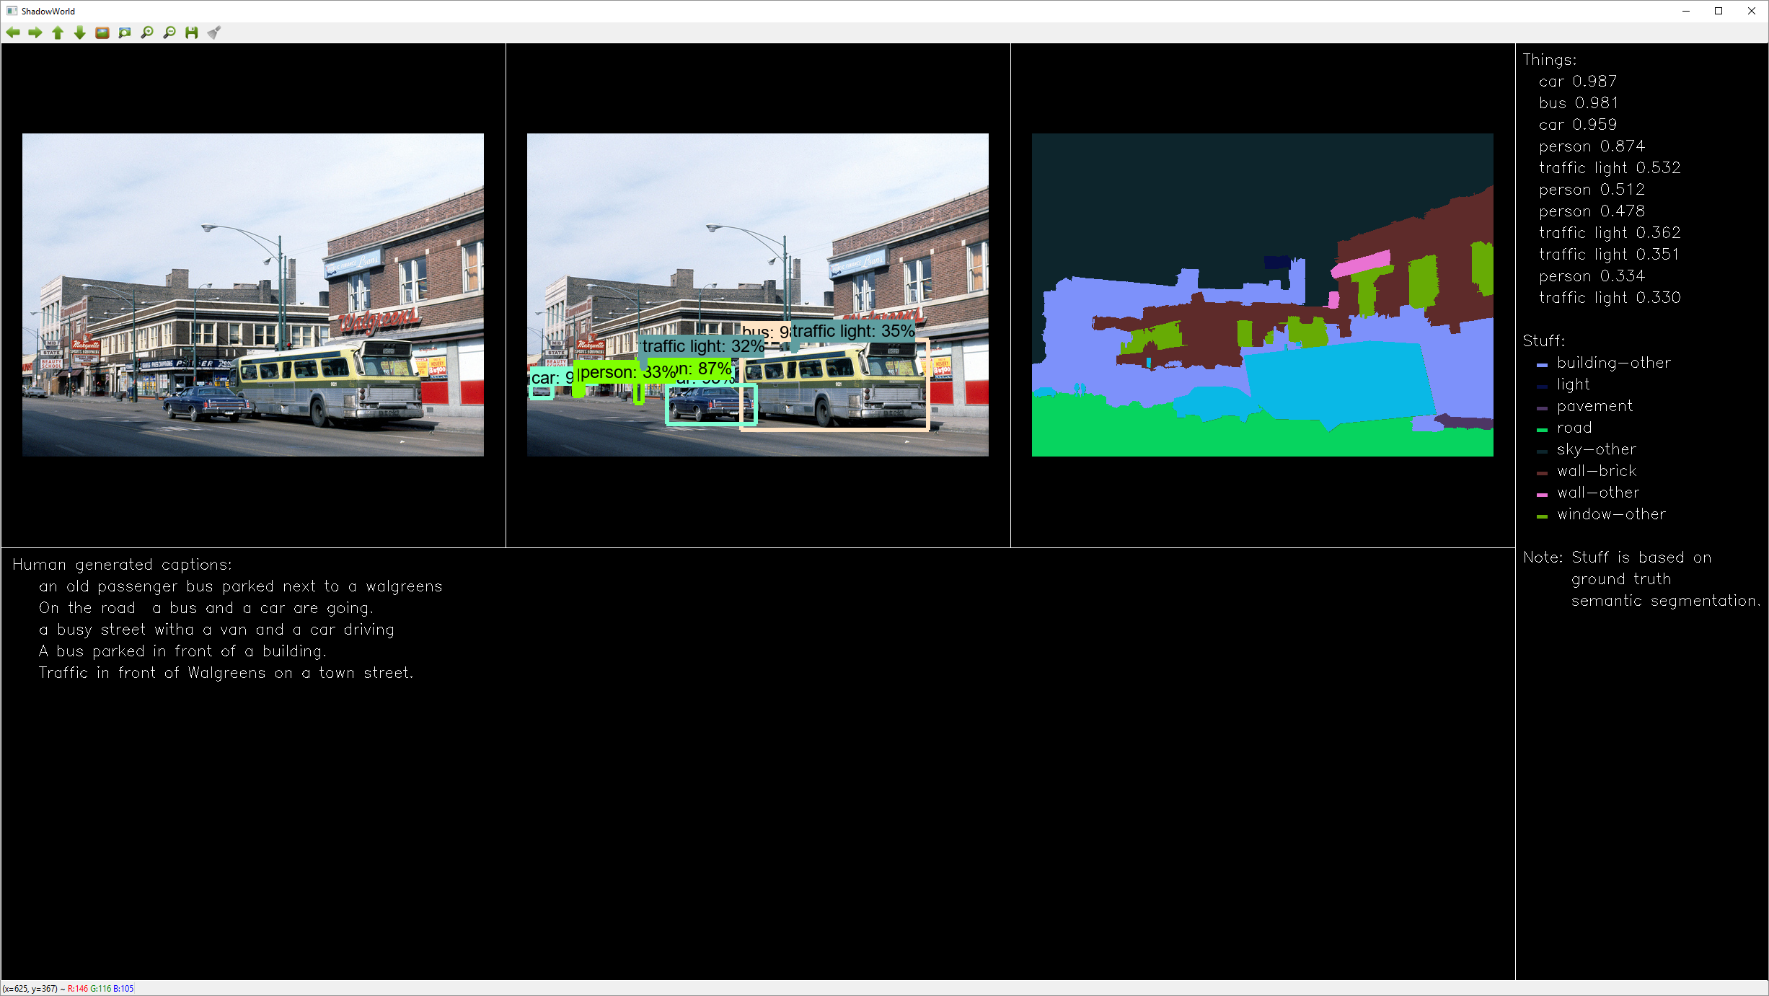

“Two cars, bus, person. Probably also four traffic lights, three persons. Building, light, pavement, road, sky, wall, window. ”

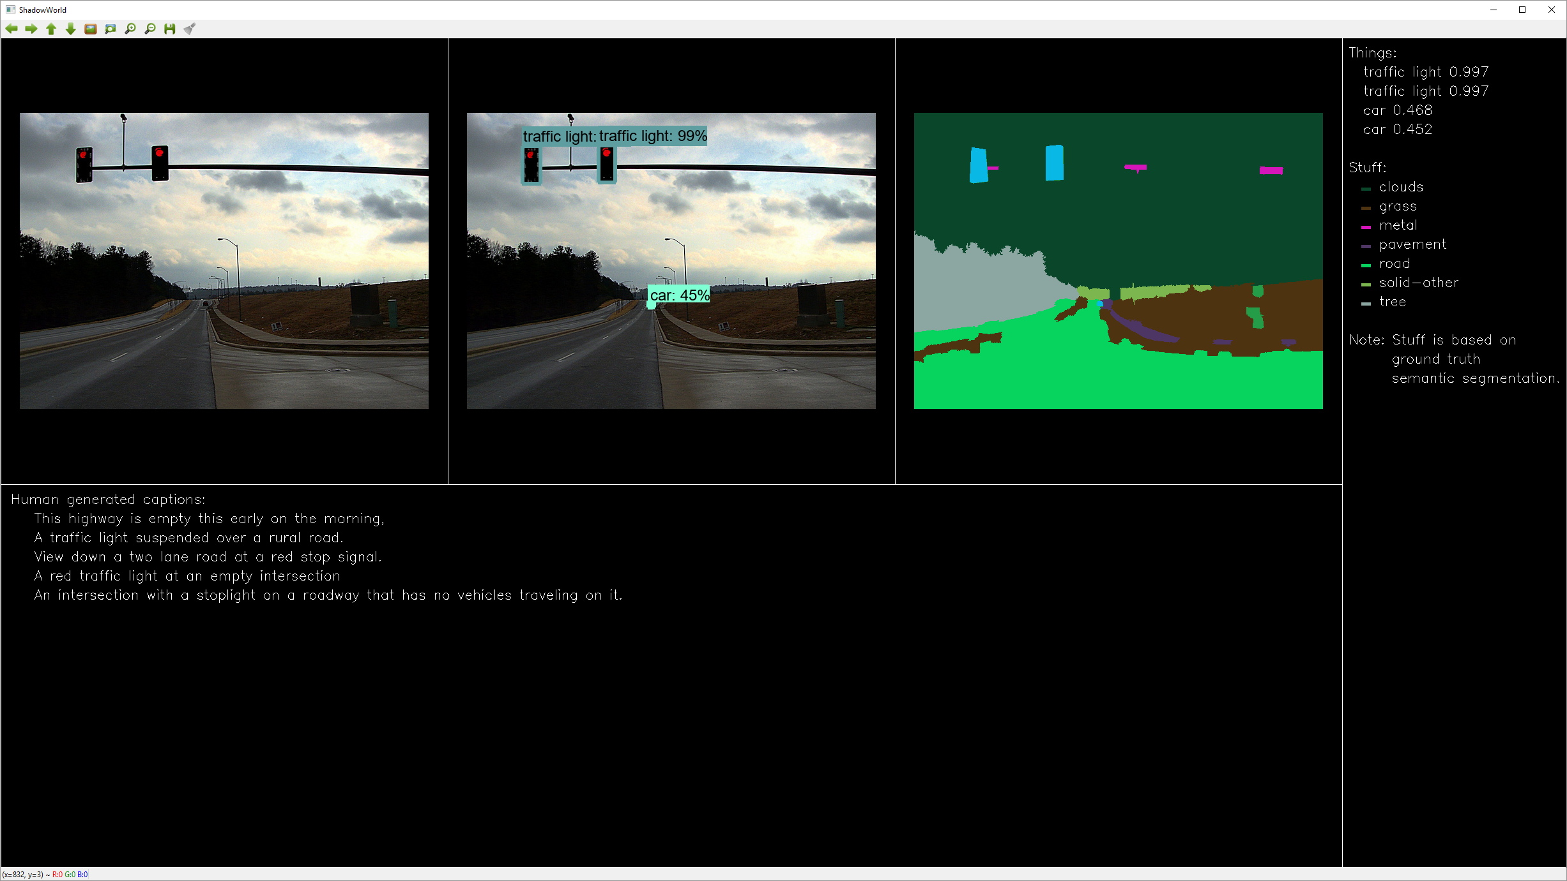

“Two traffic lights. Probably also two cars. Clouds, grass, metal, pavement, road, tree.”

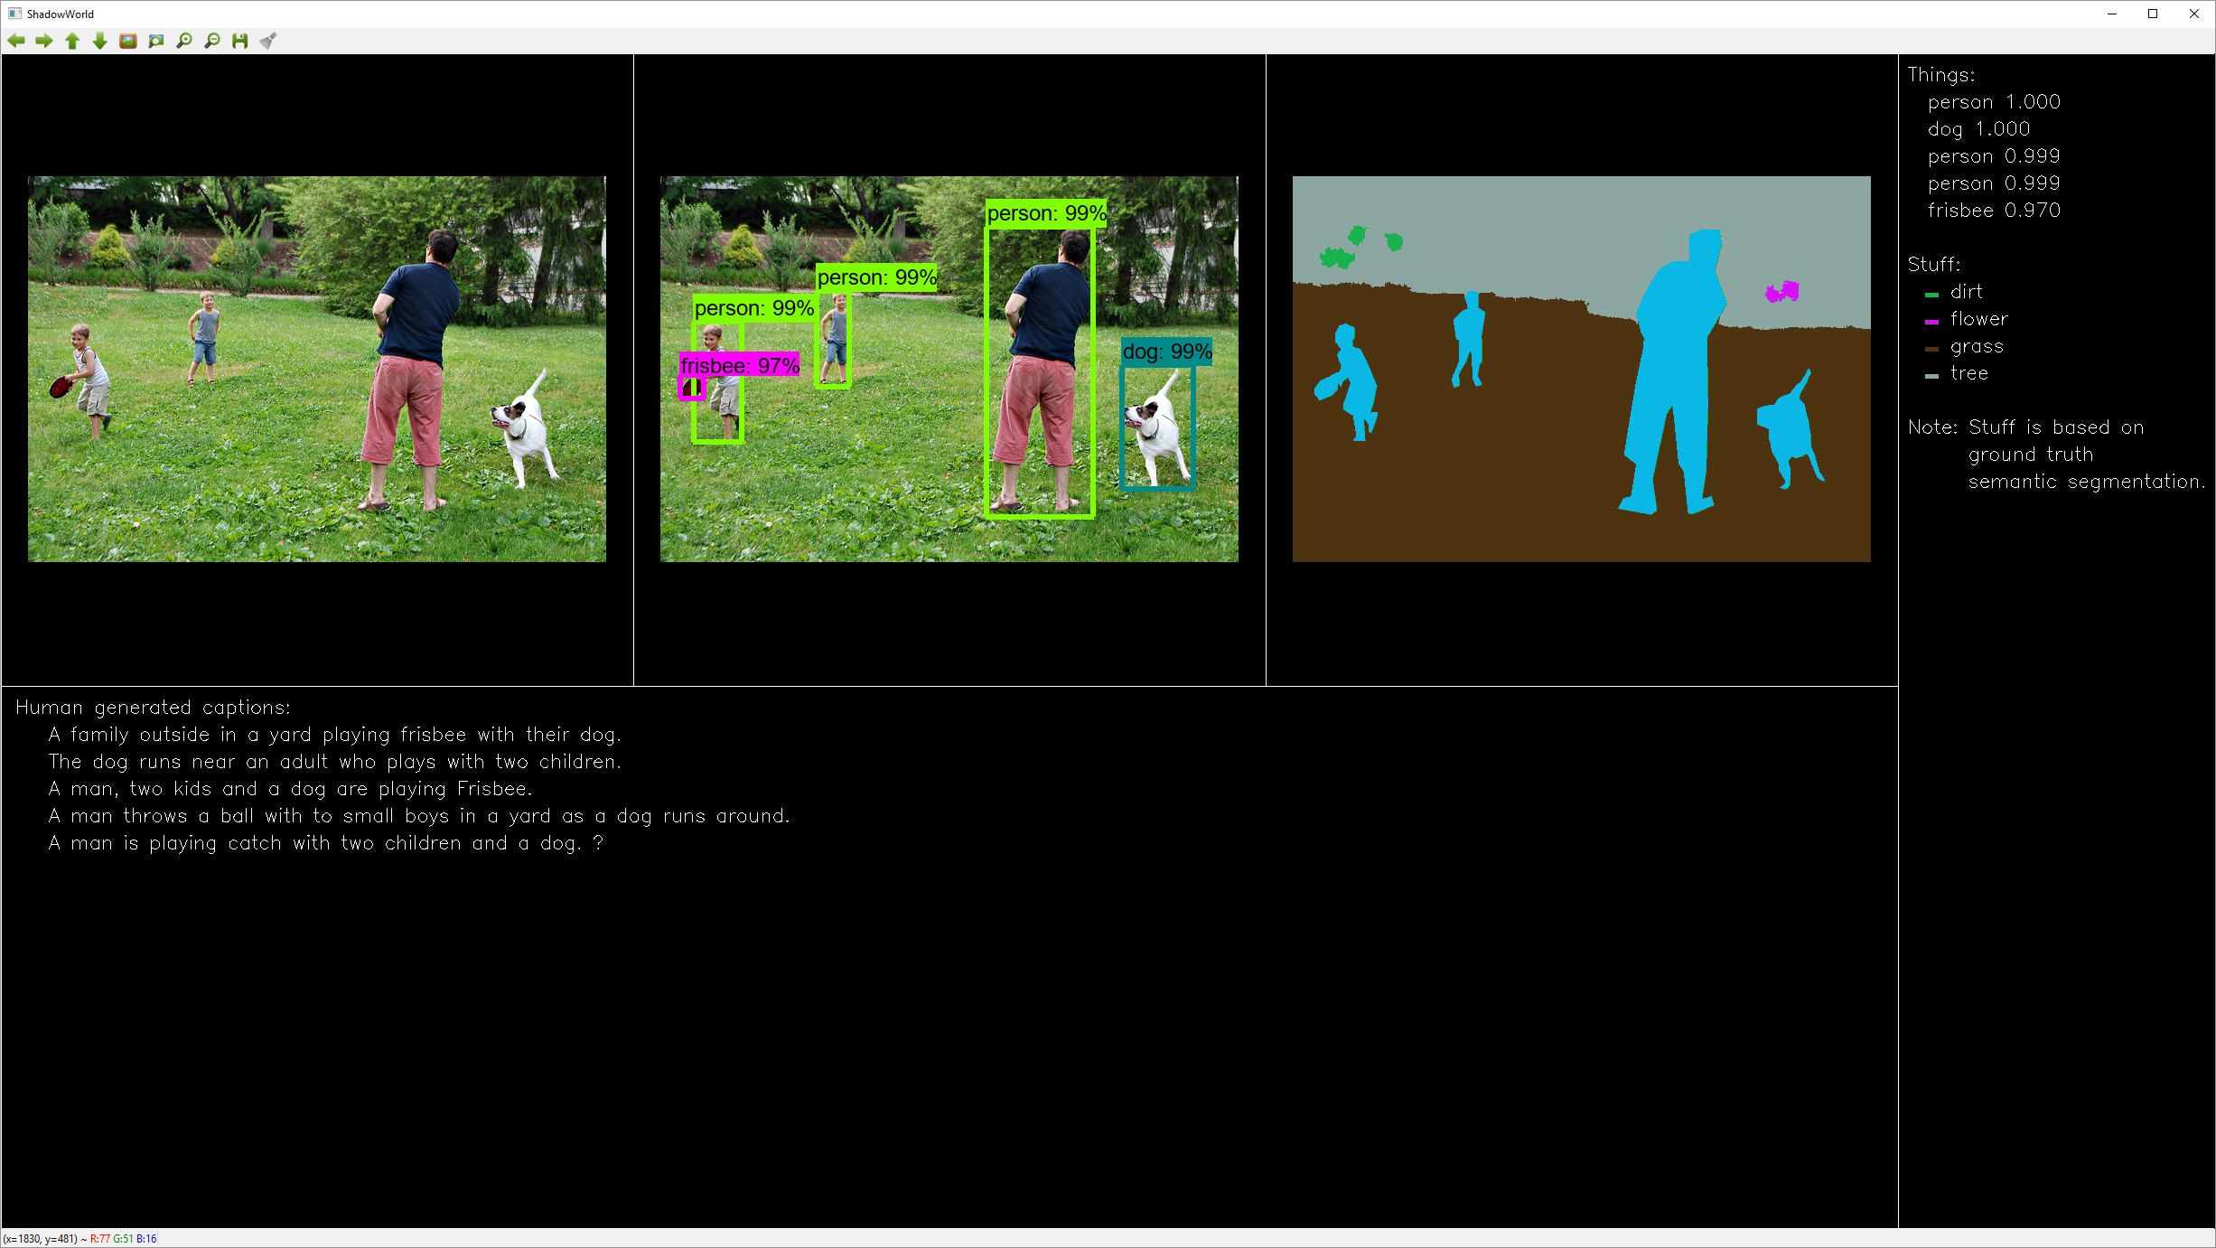

“Three persons, dog, frisbee. Dirt, grass, tree.”

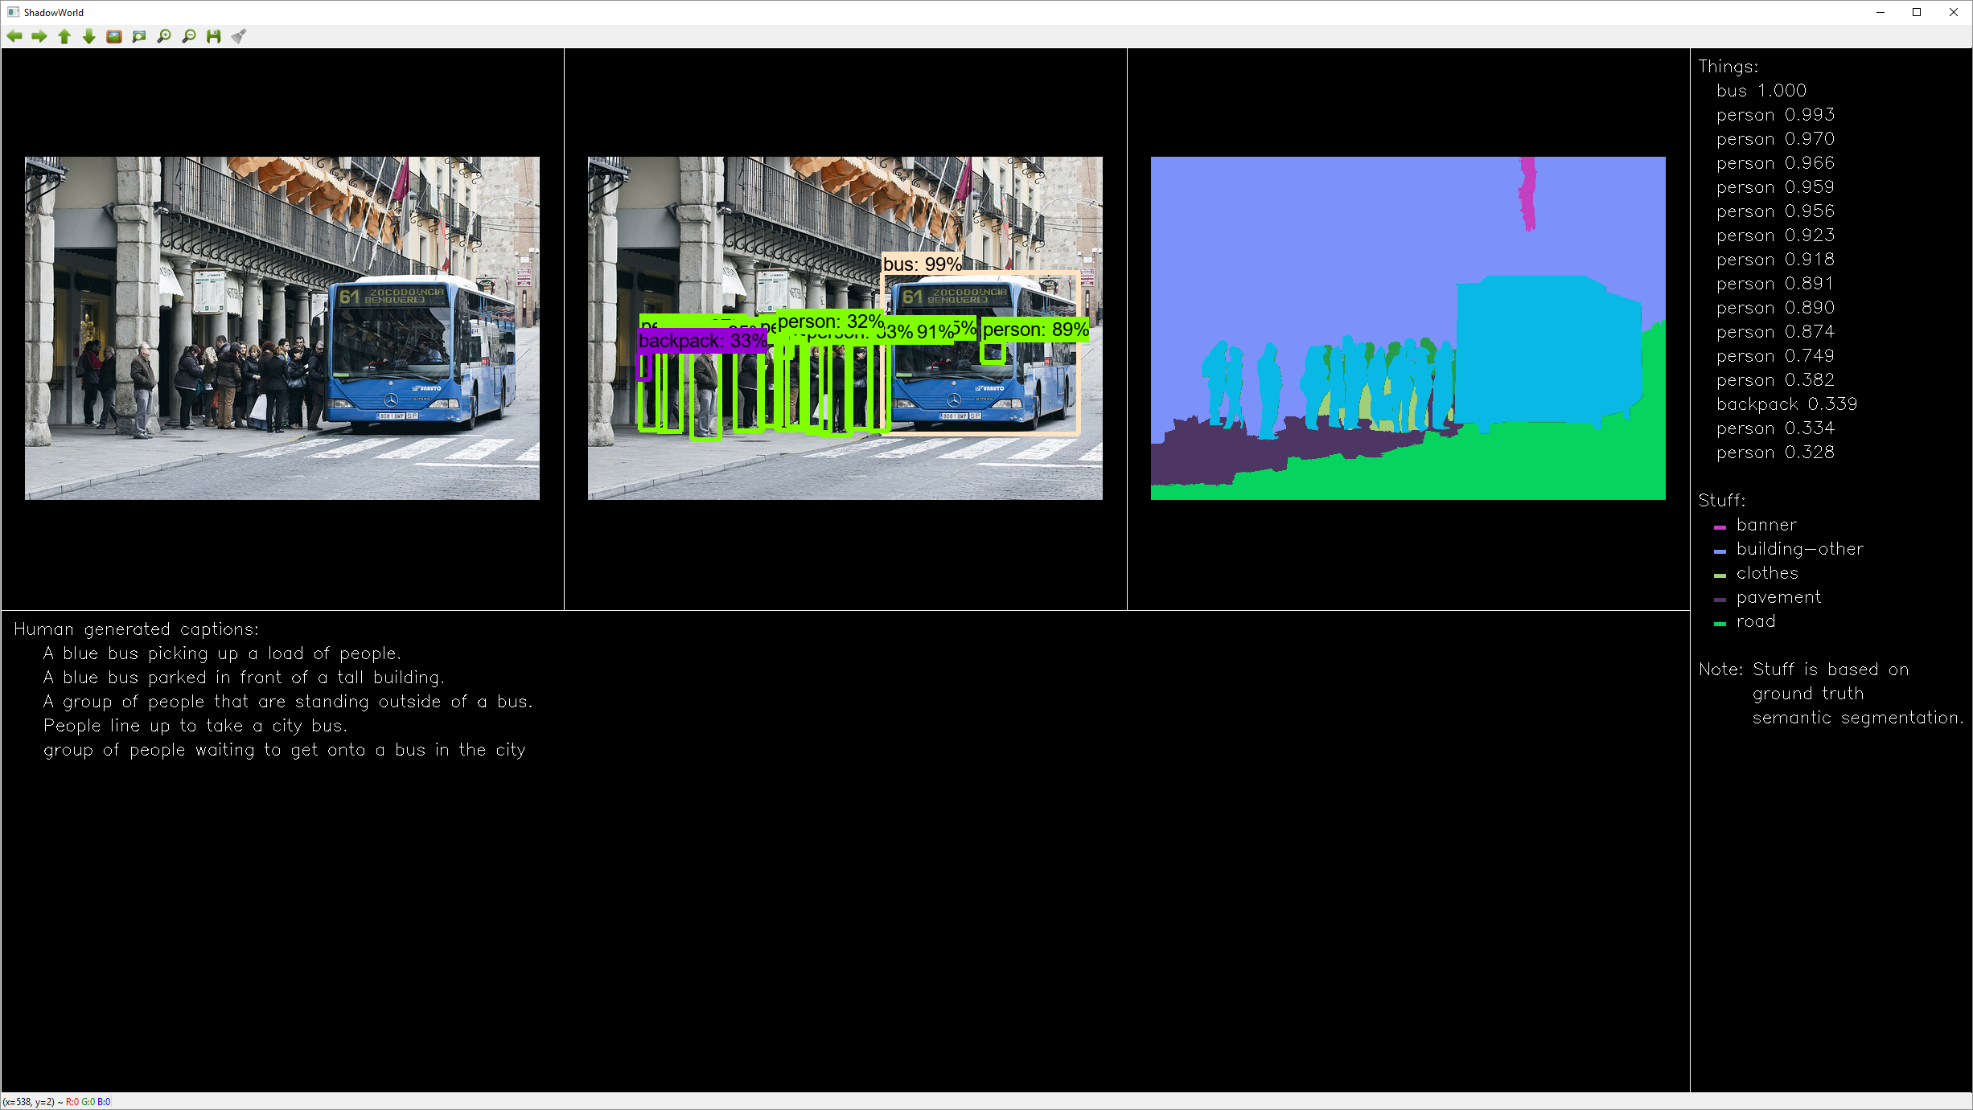

“Bus, ten people. Probably also seven people, backpack. Banner, building, clothes, pavement, road.”

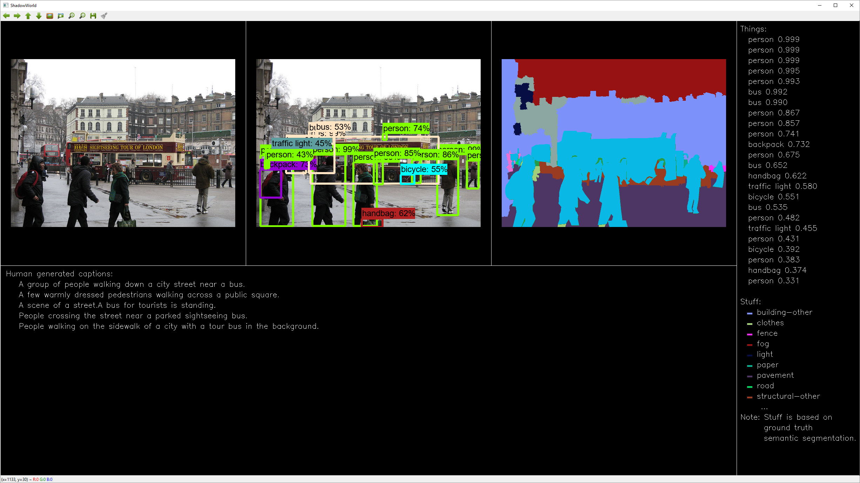

“Seven persons, two buses. Probably also backpack, two buses, two handbags, two traffic lights, two bicycles. Building, clothes, fence, fog, light, paper, pavement, road.

## 3.2 Where is {thing}?

The answer is formed for each instance of {thing} class. If not present, “No {thing}”.

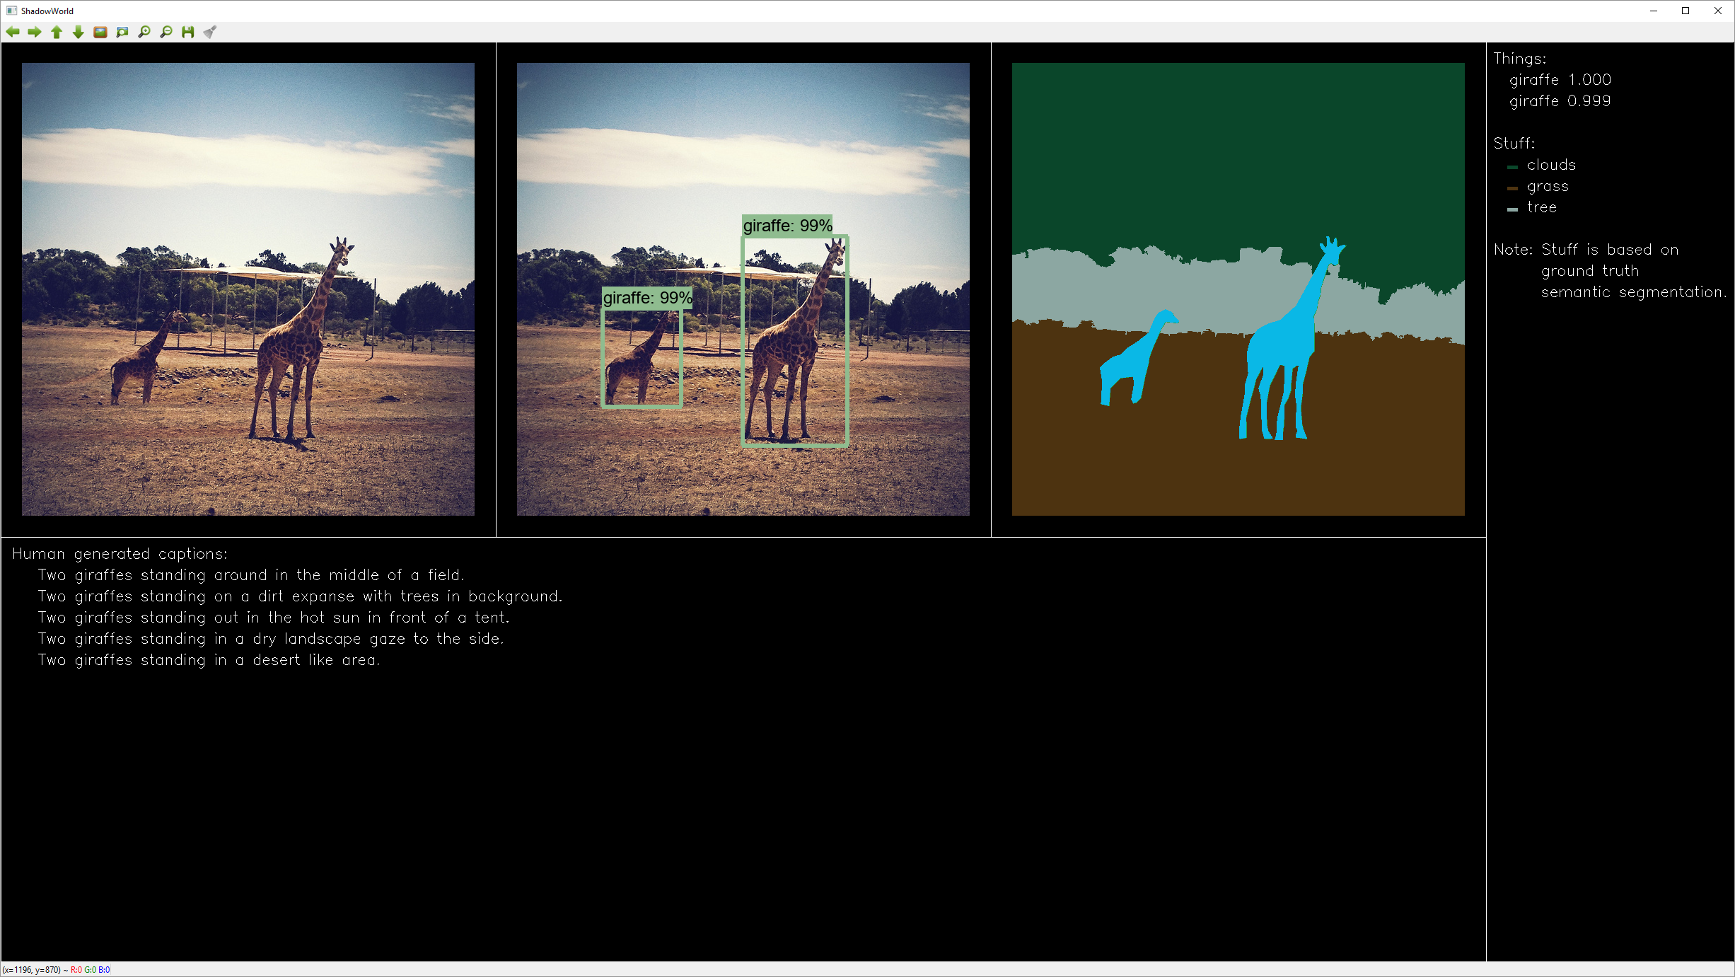

“Where is giraffe?”

“Distance 15 meters, right 5 degrees, down 4 degrees. Distance 25 meters, left 7 degrees, down 6 degrees.”



“Where is car?”

“No car”

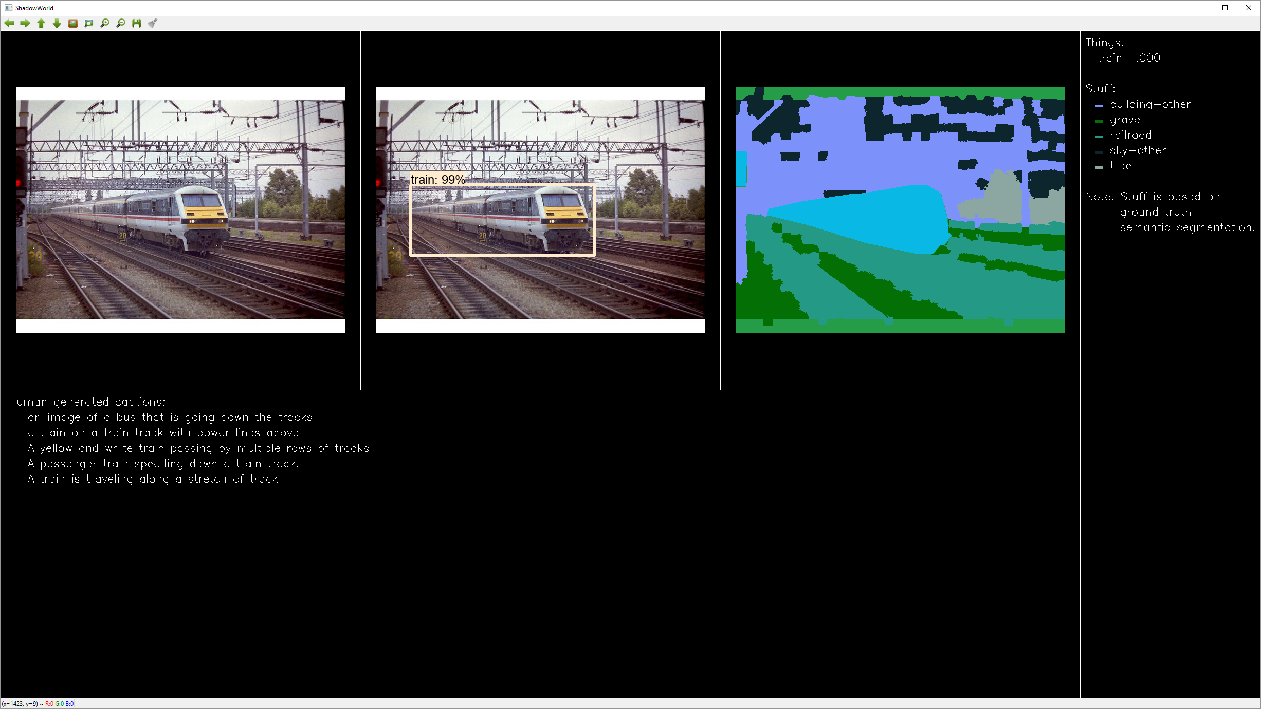

“Where is train?”

“Distance 55 meters, left 10 degrees, down 5 degrees.”

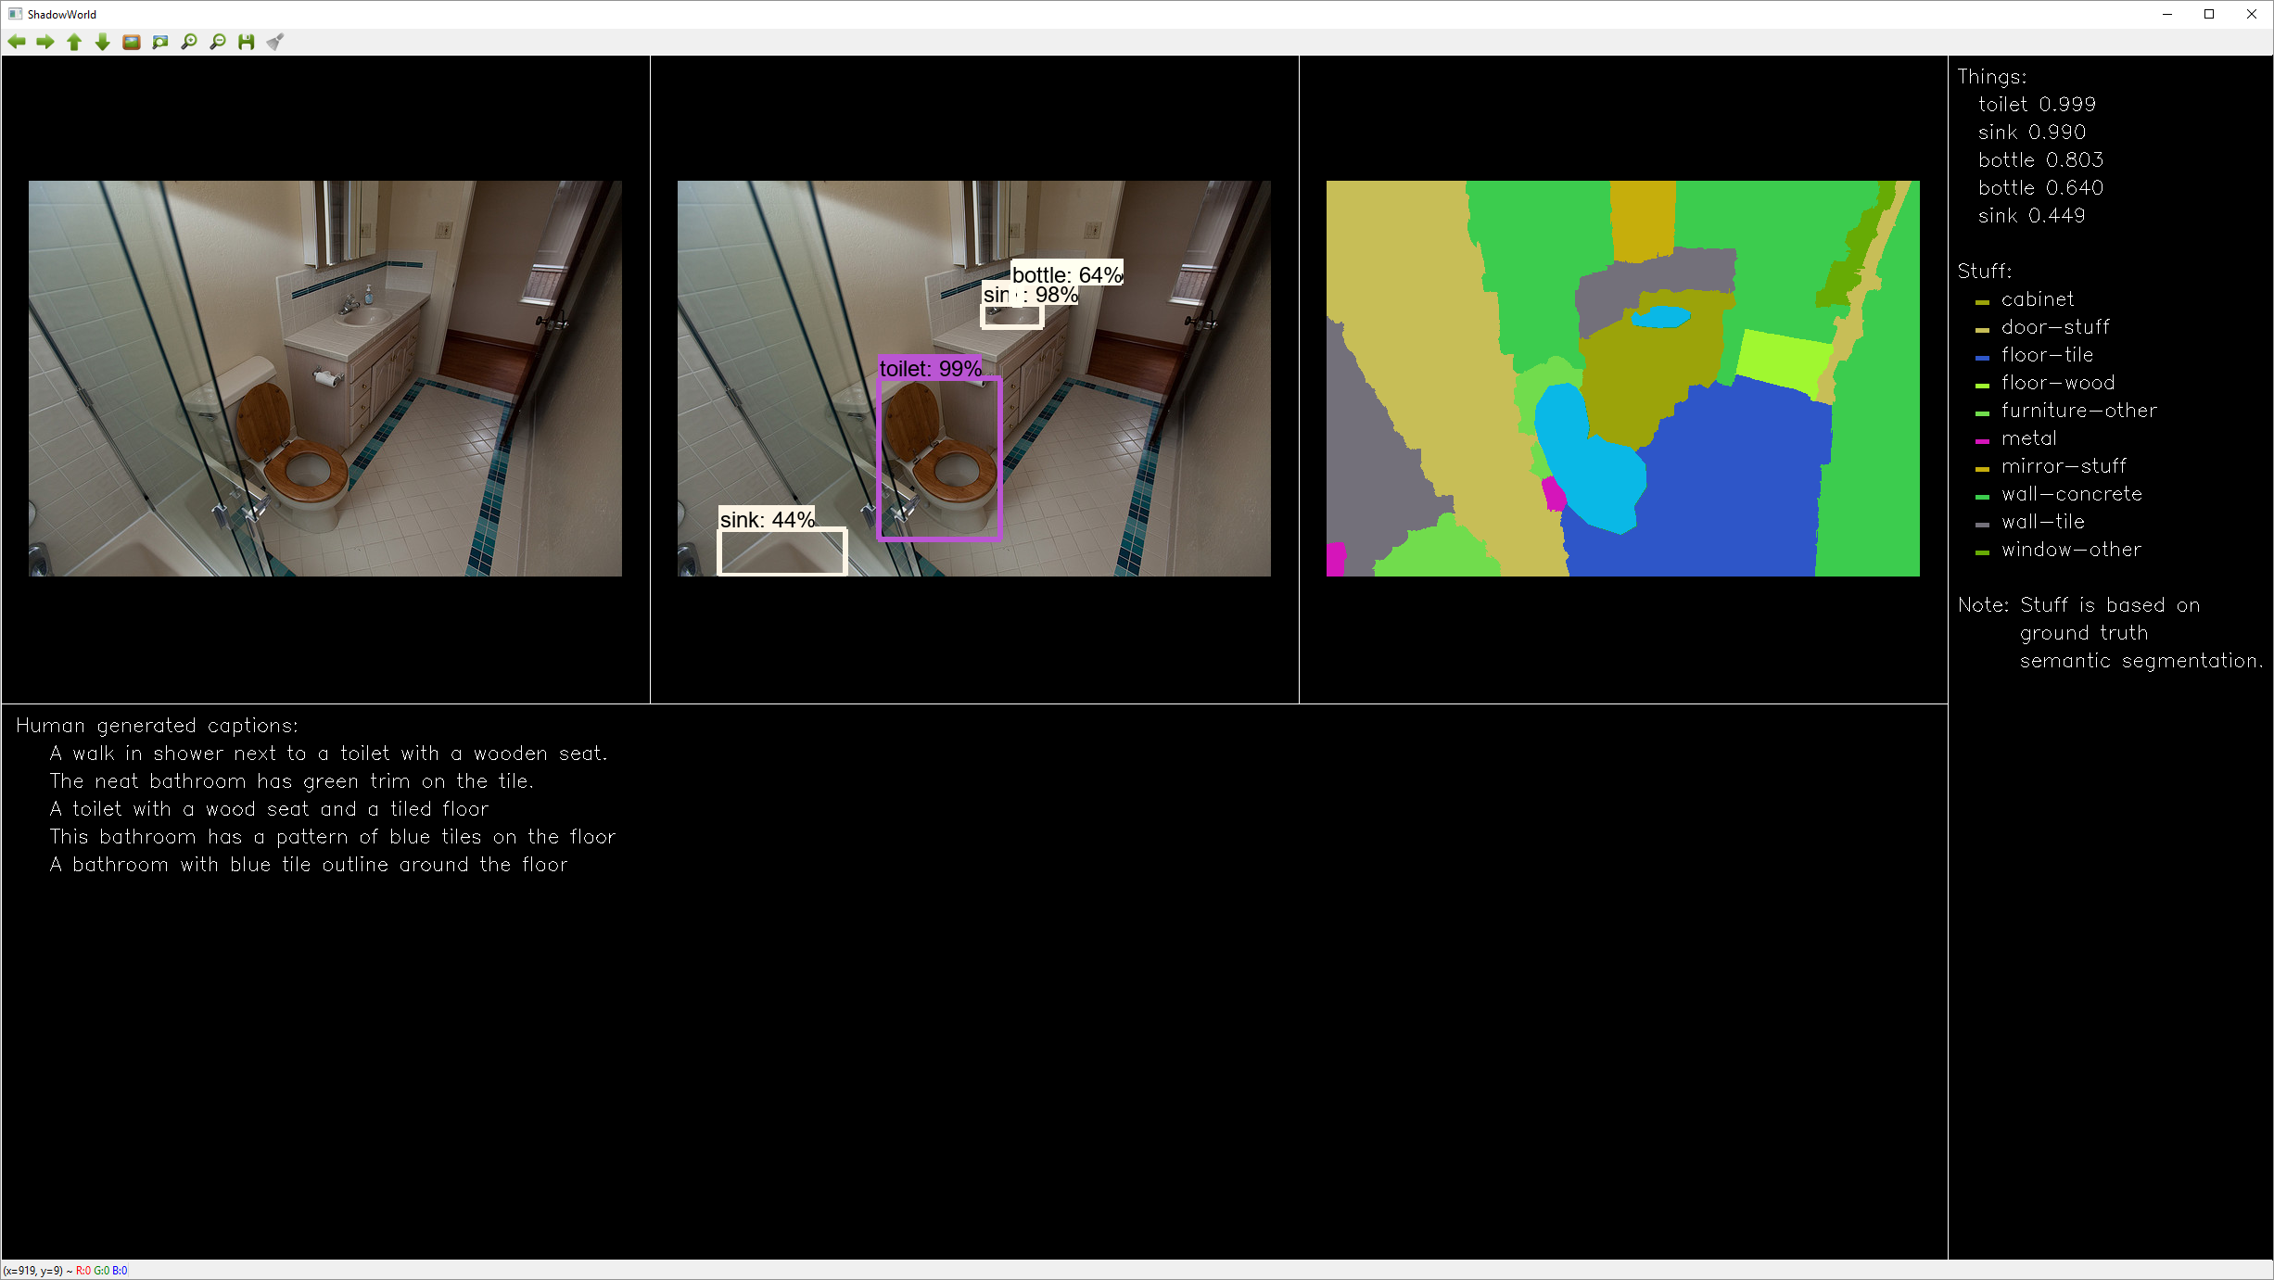

“Where is bottle?”

“Distance 6 meters, right 2 degrees, up 4 degrees.”

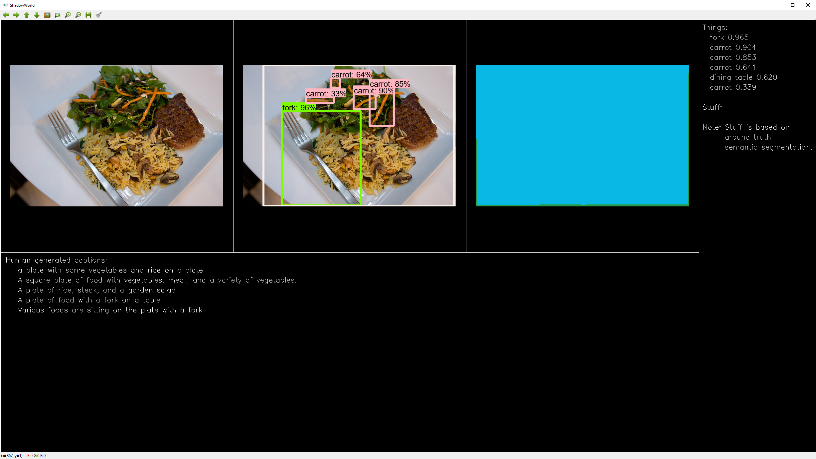

“Where is fork?”

“Distance 45 centimetres, left 20 degrees, down 15 degrees.”